Willis Allstead

4/11/18

CS 491

Lab 5

**Sentiment Analysis**

#1:

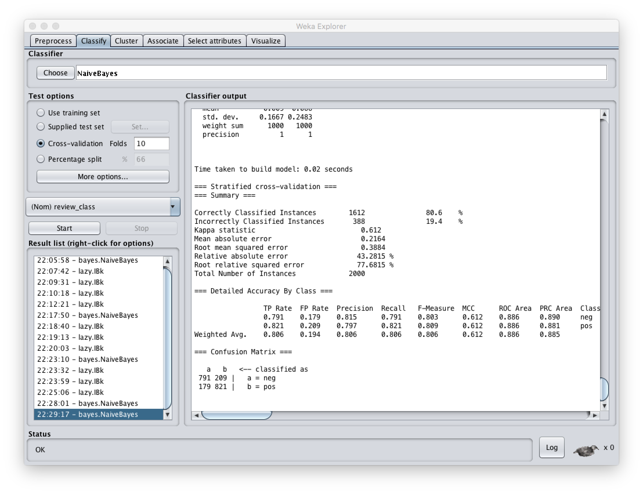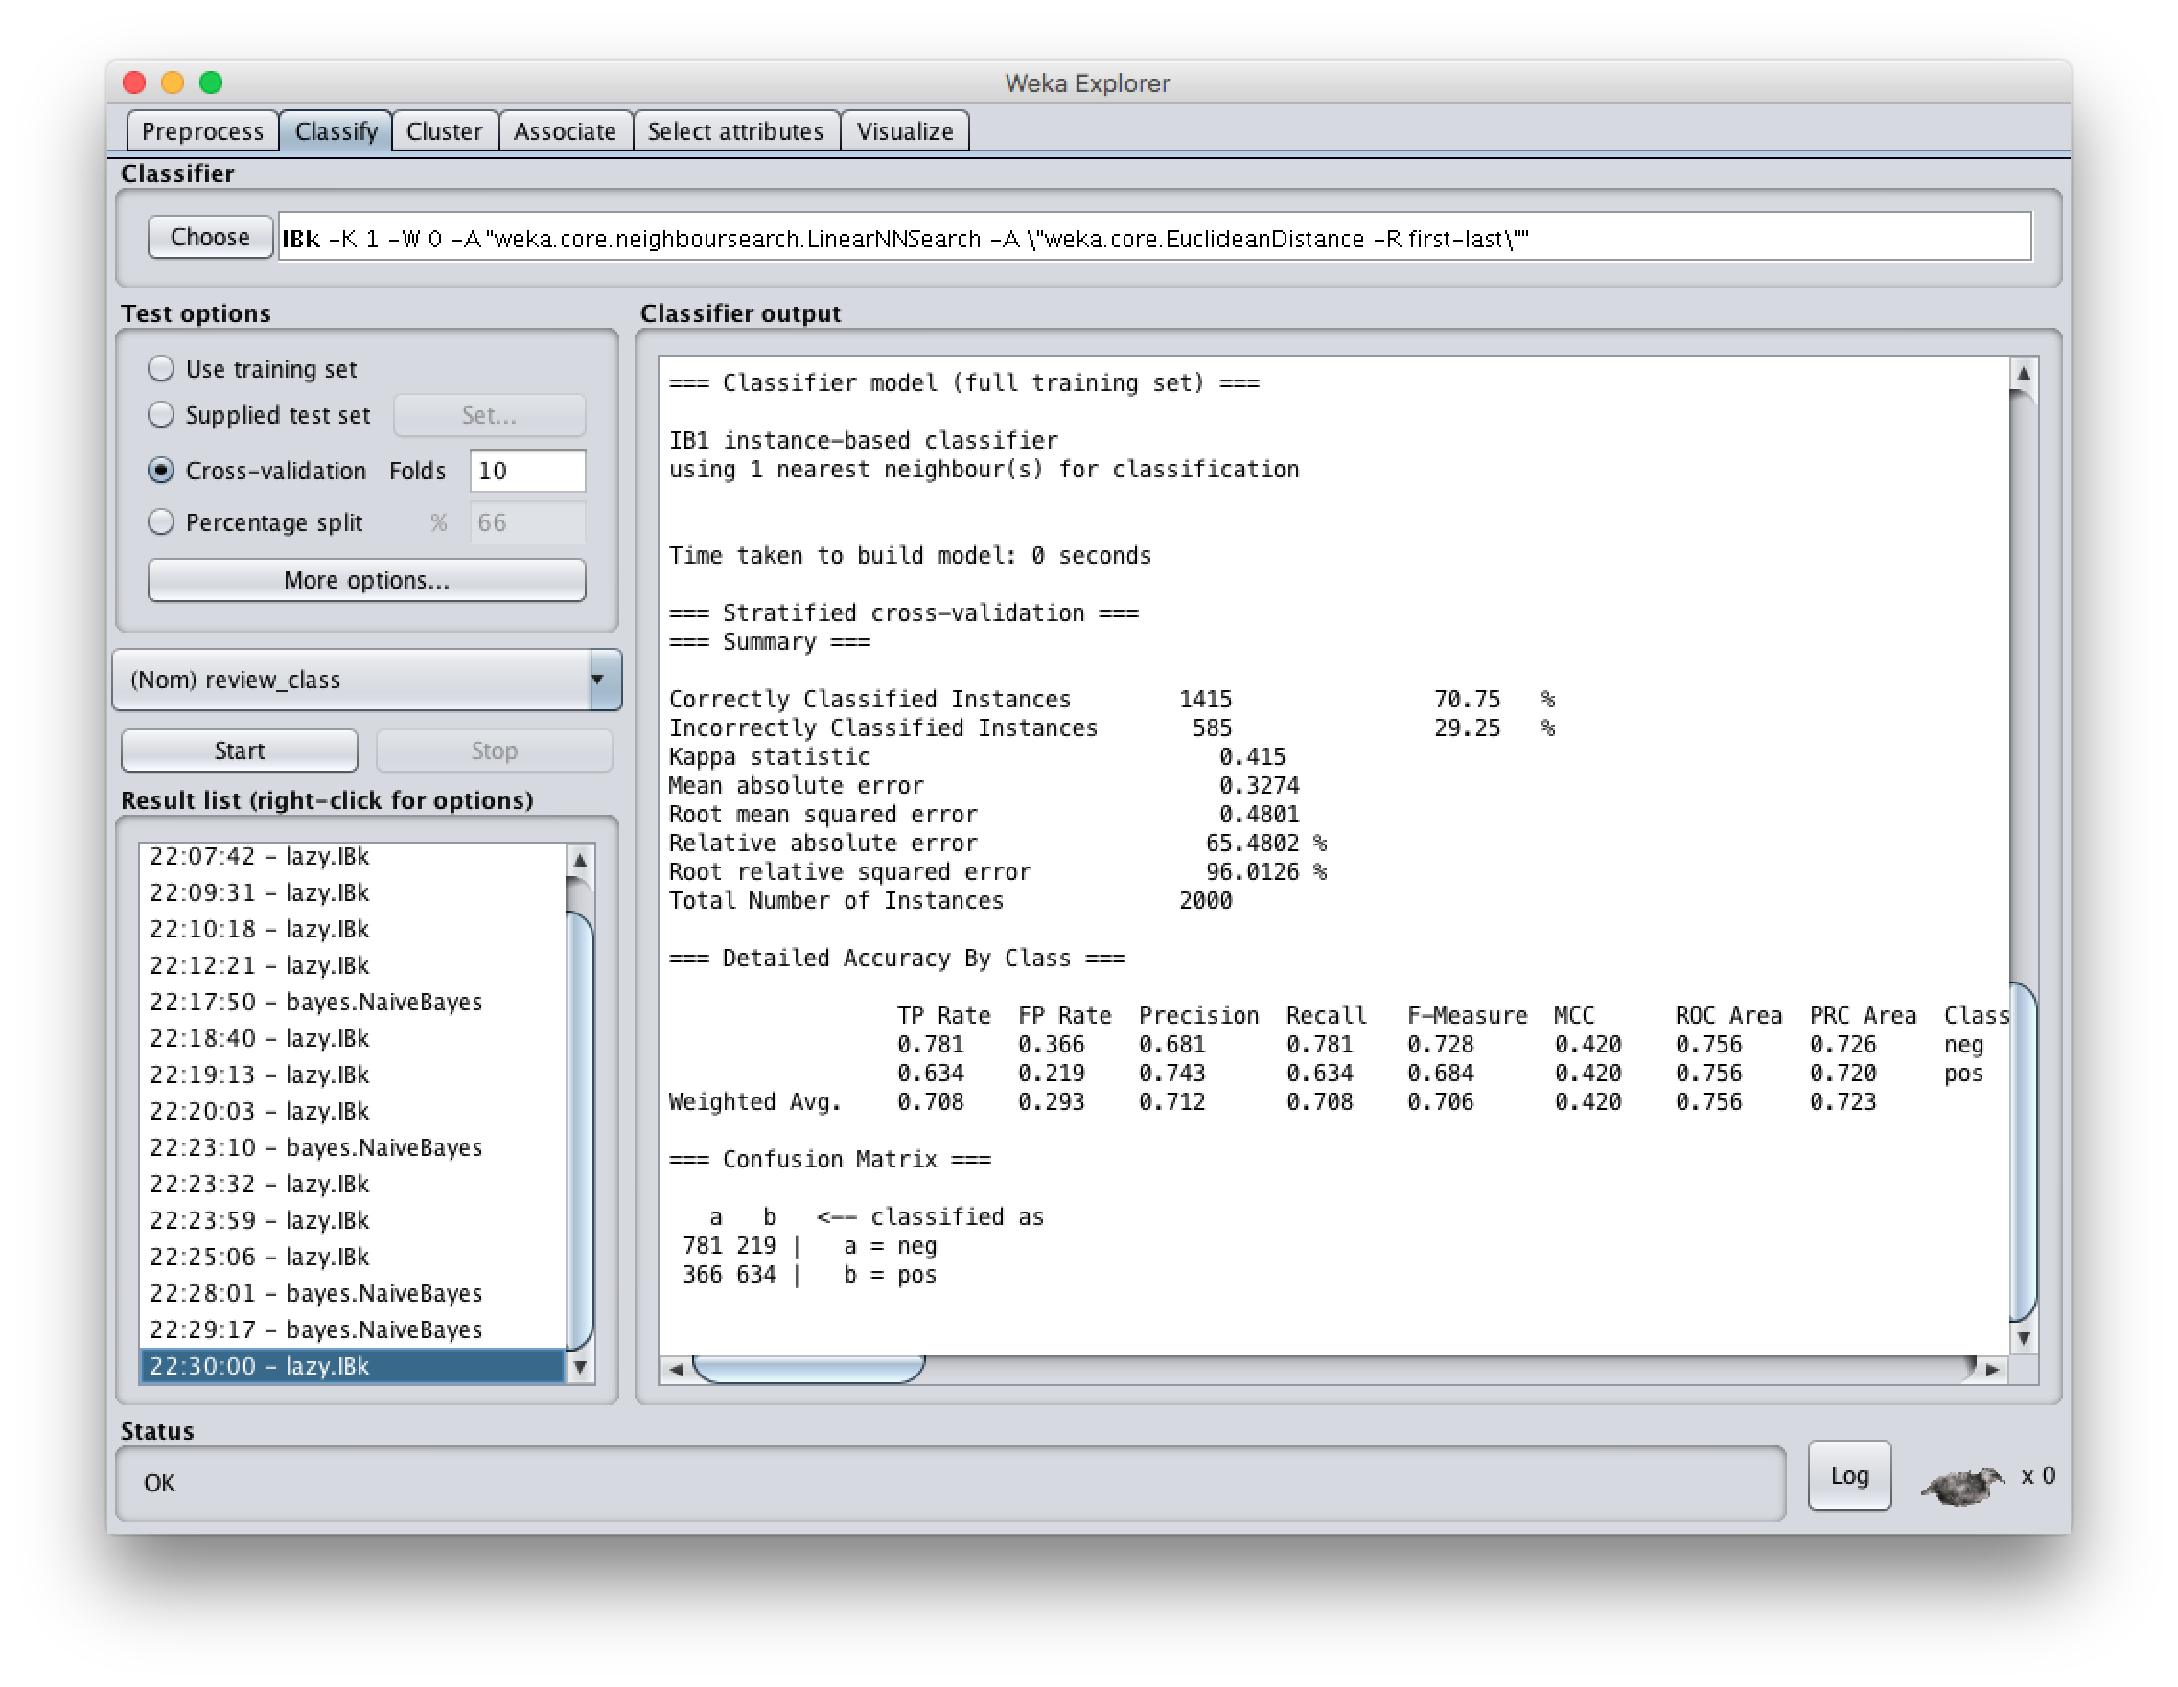

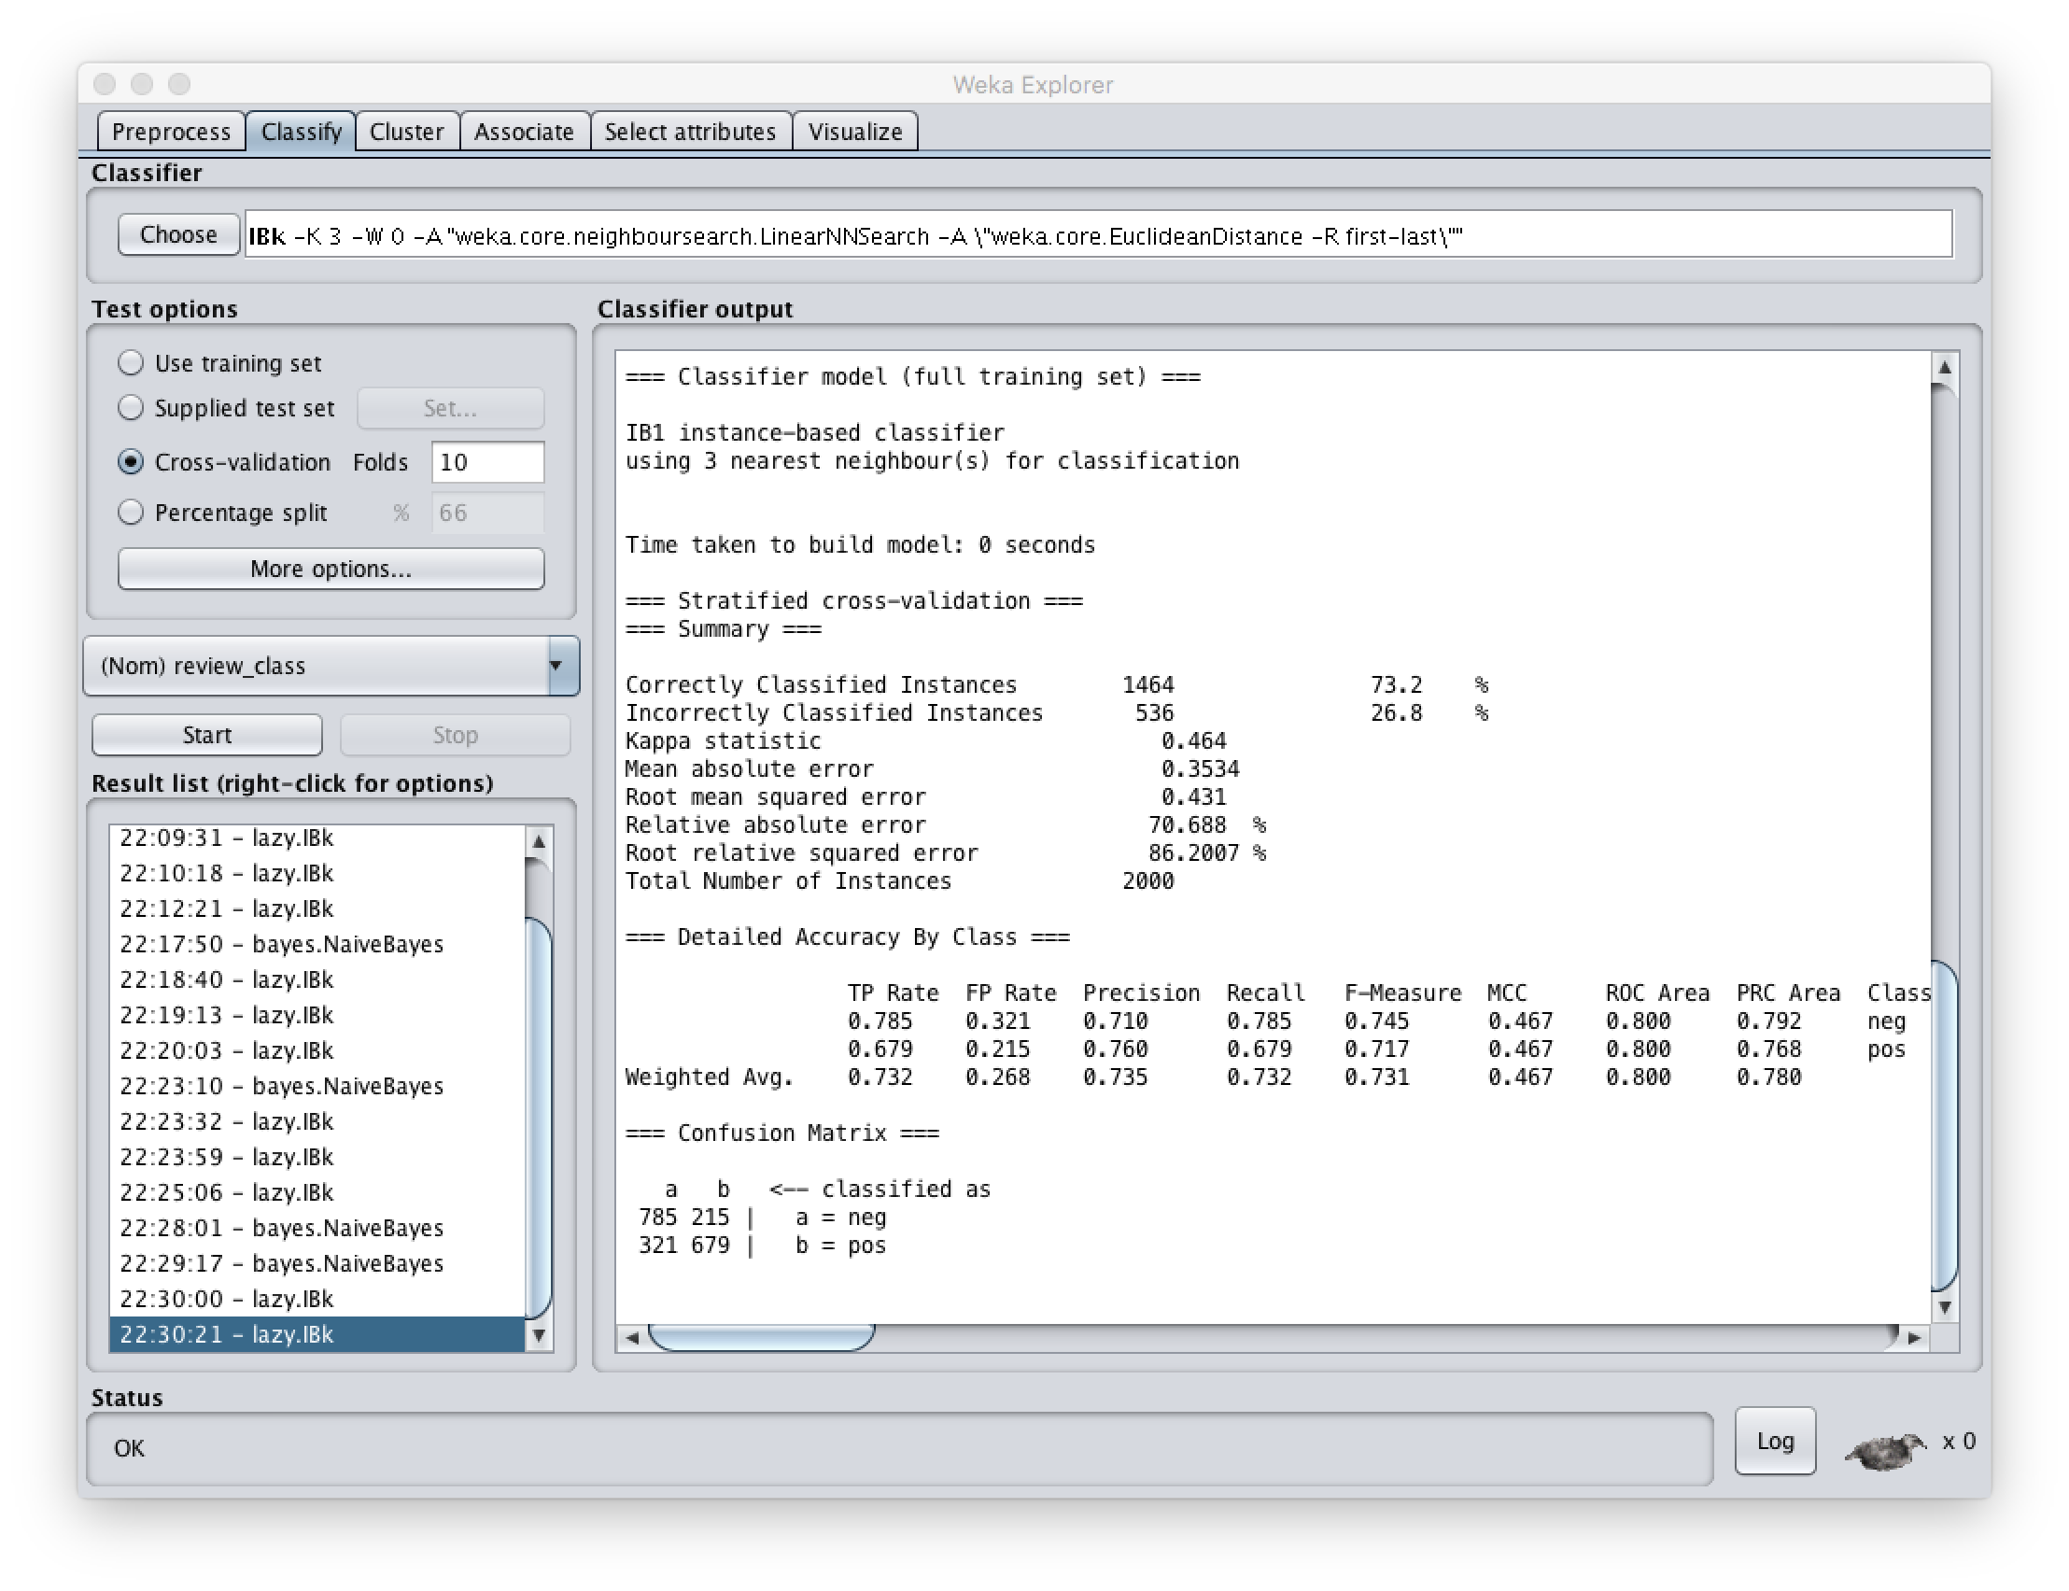

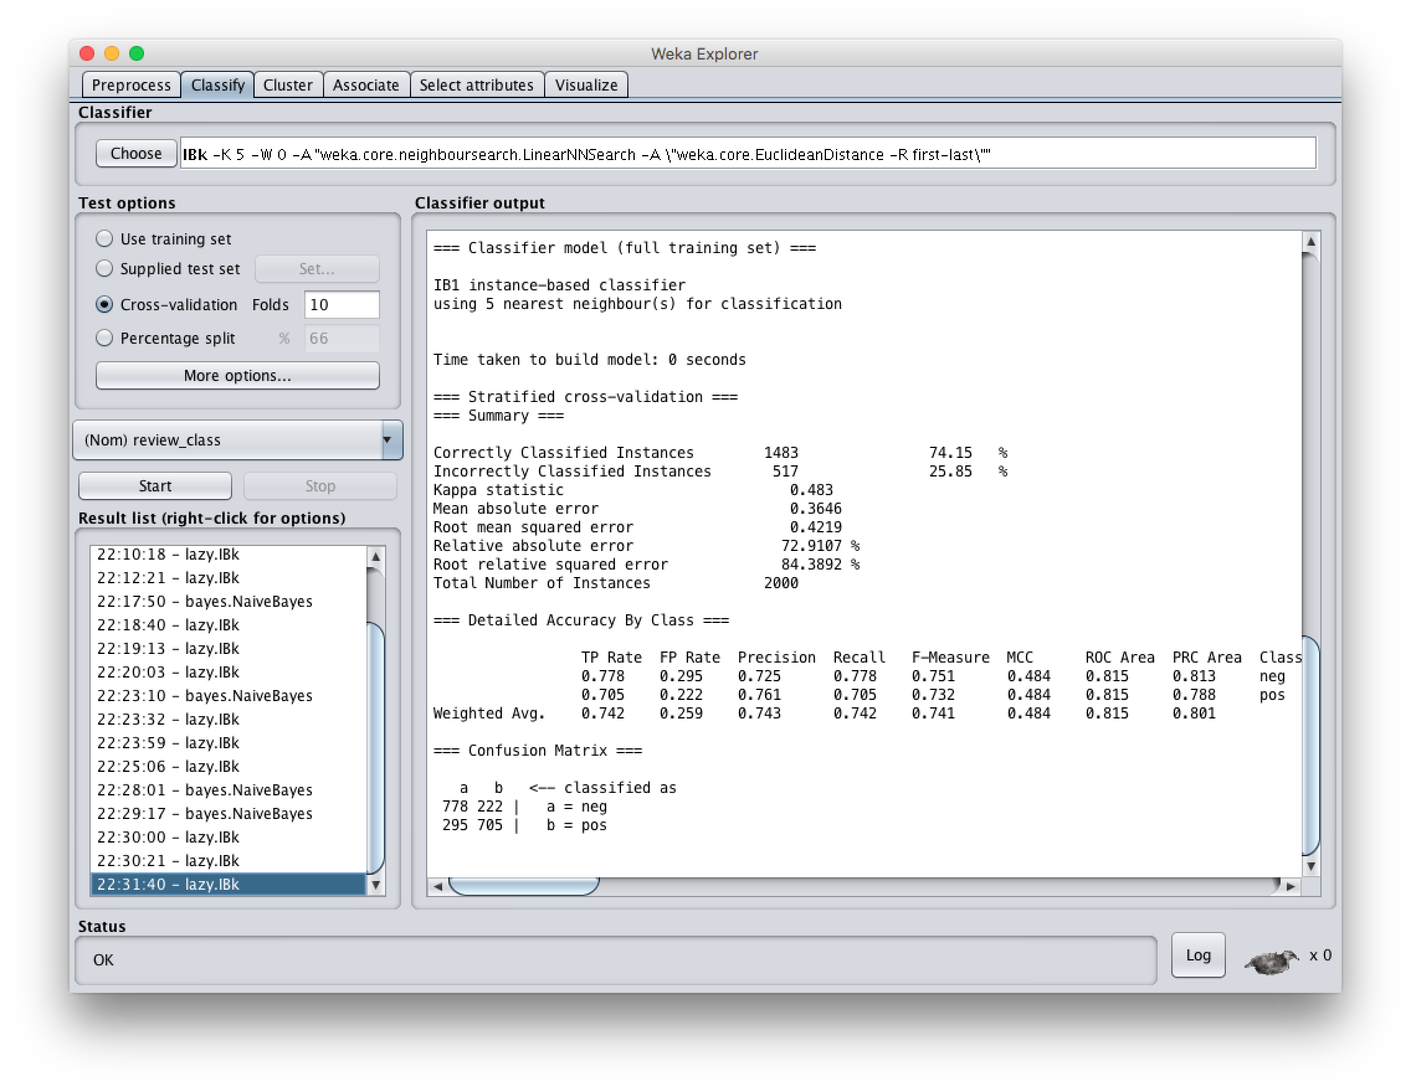

#2:

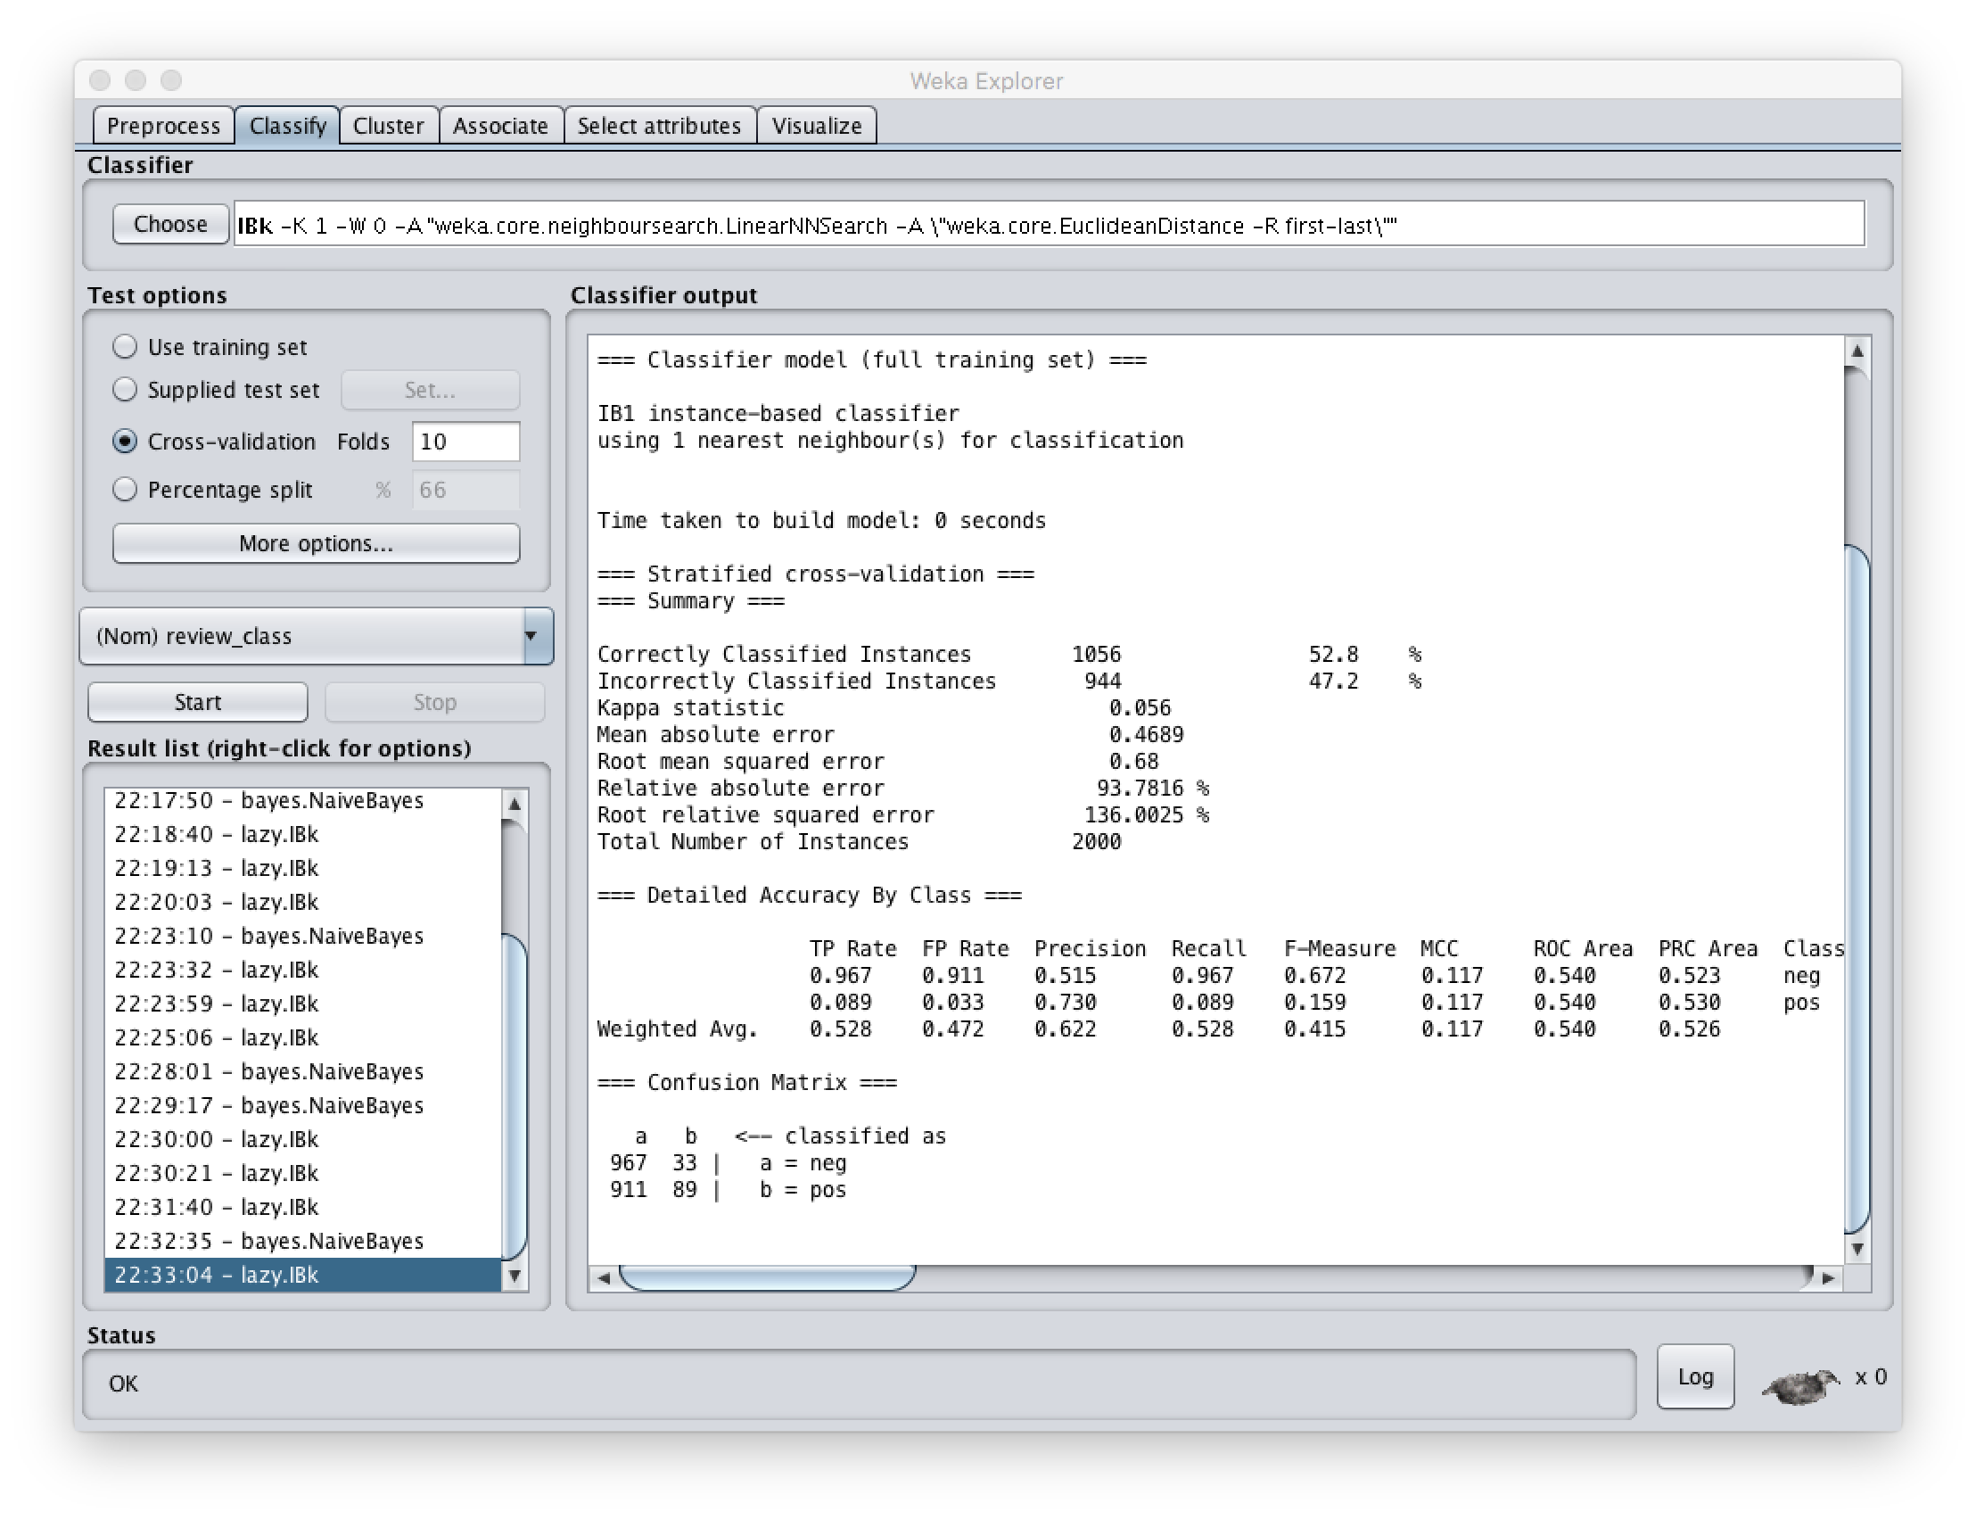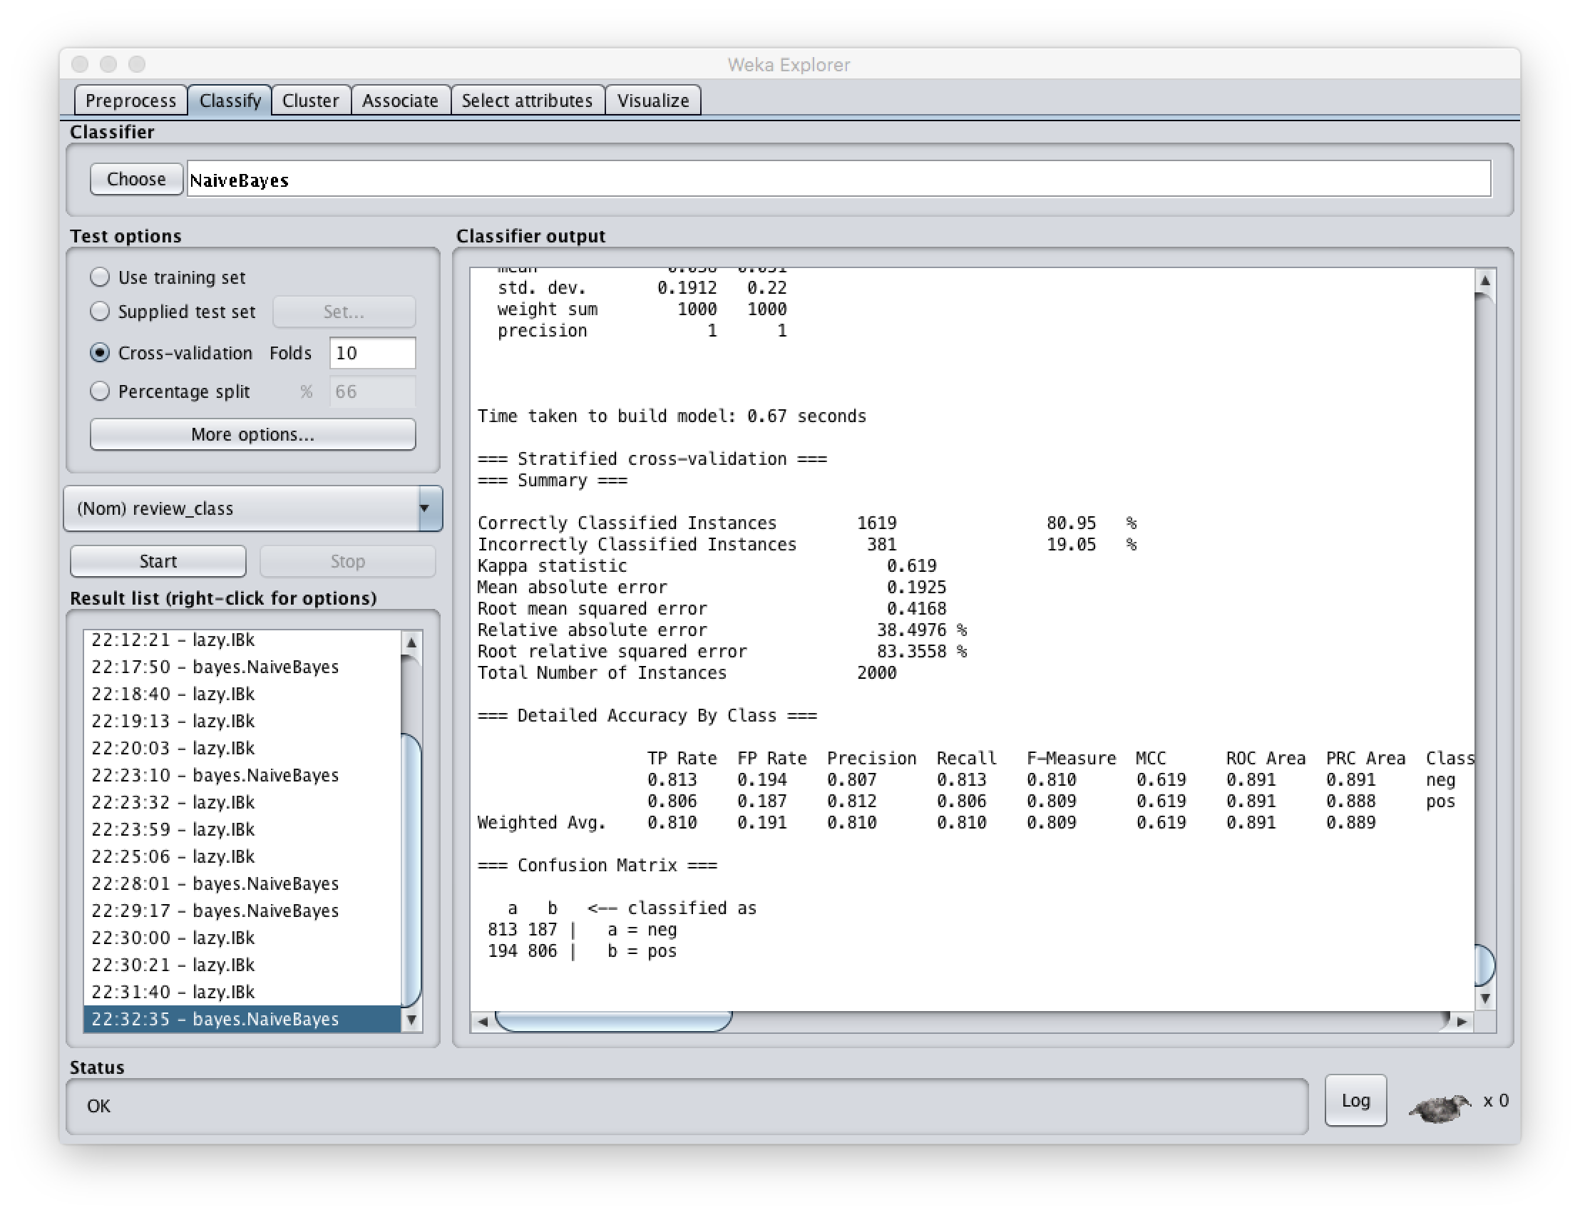

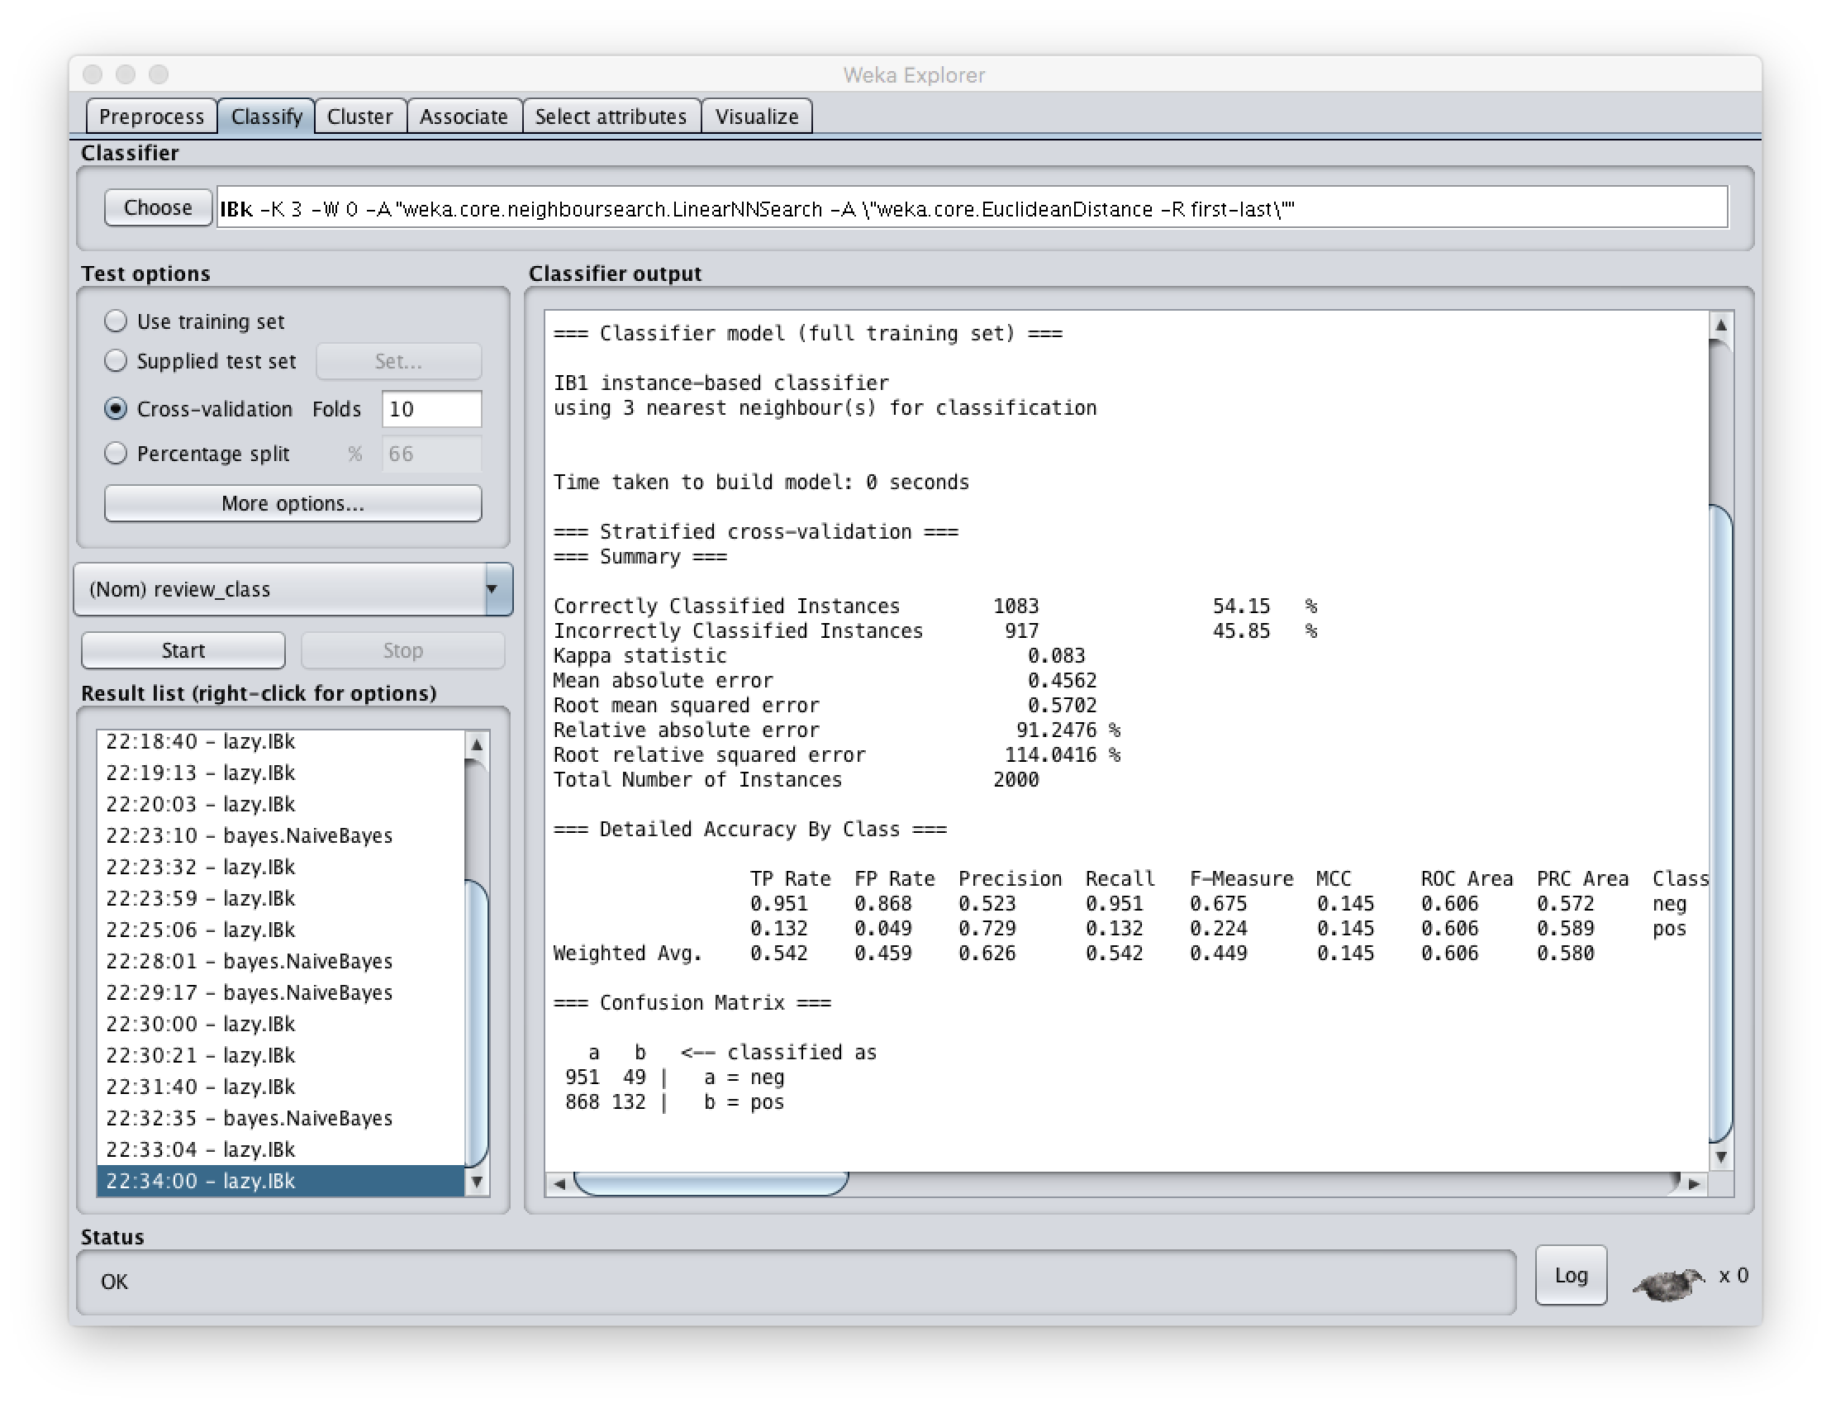

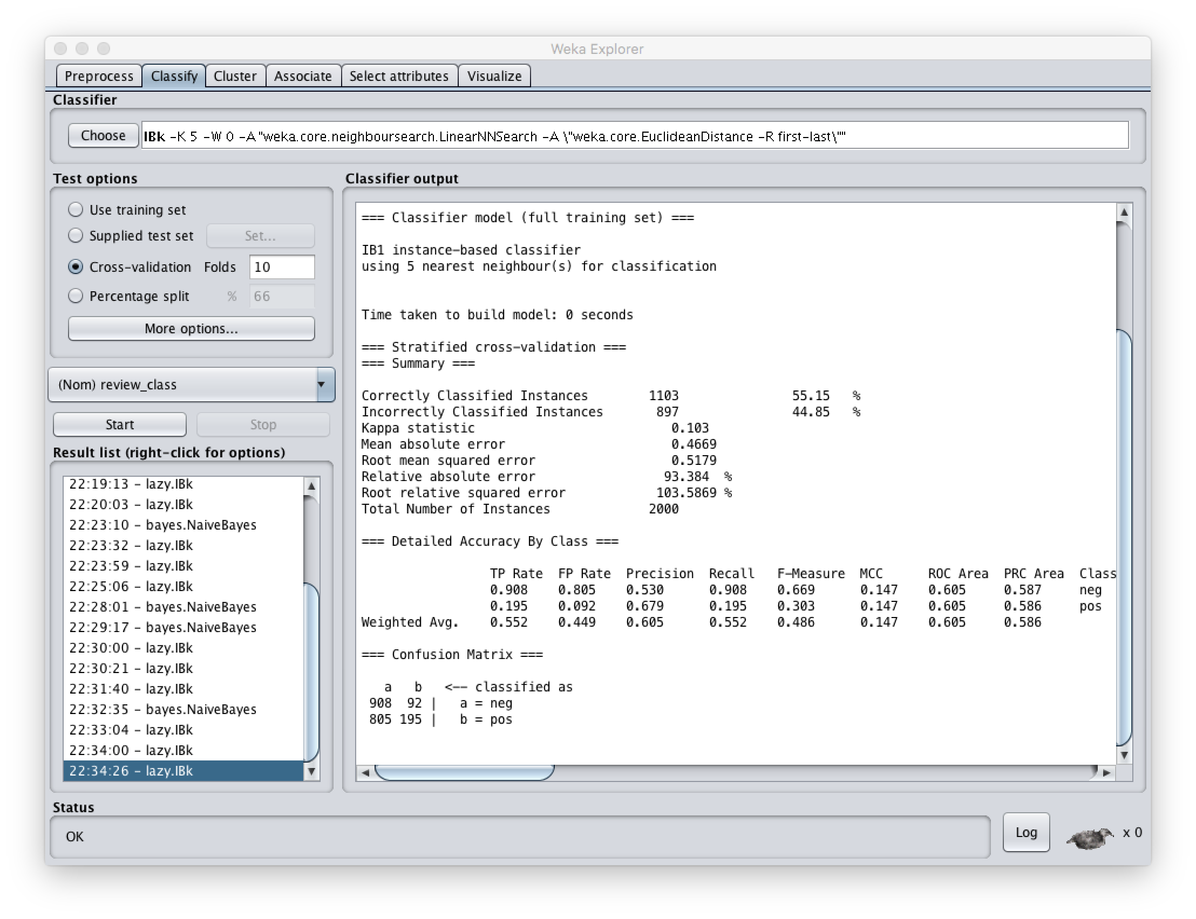

#3:

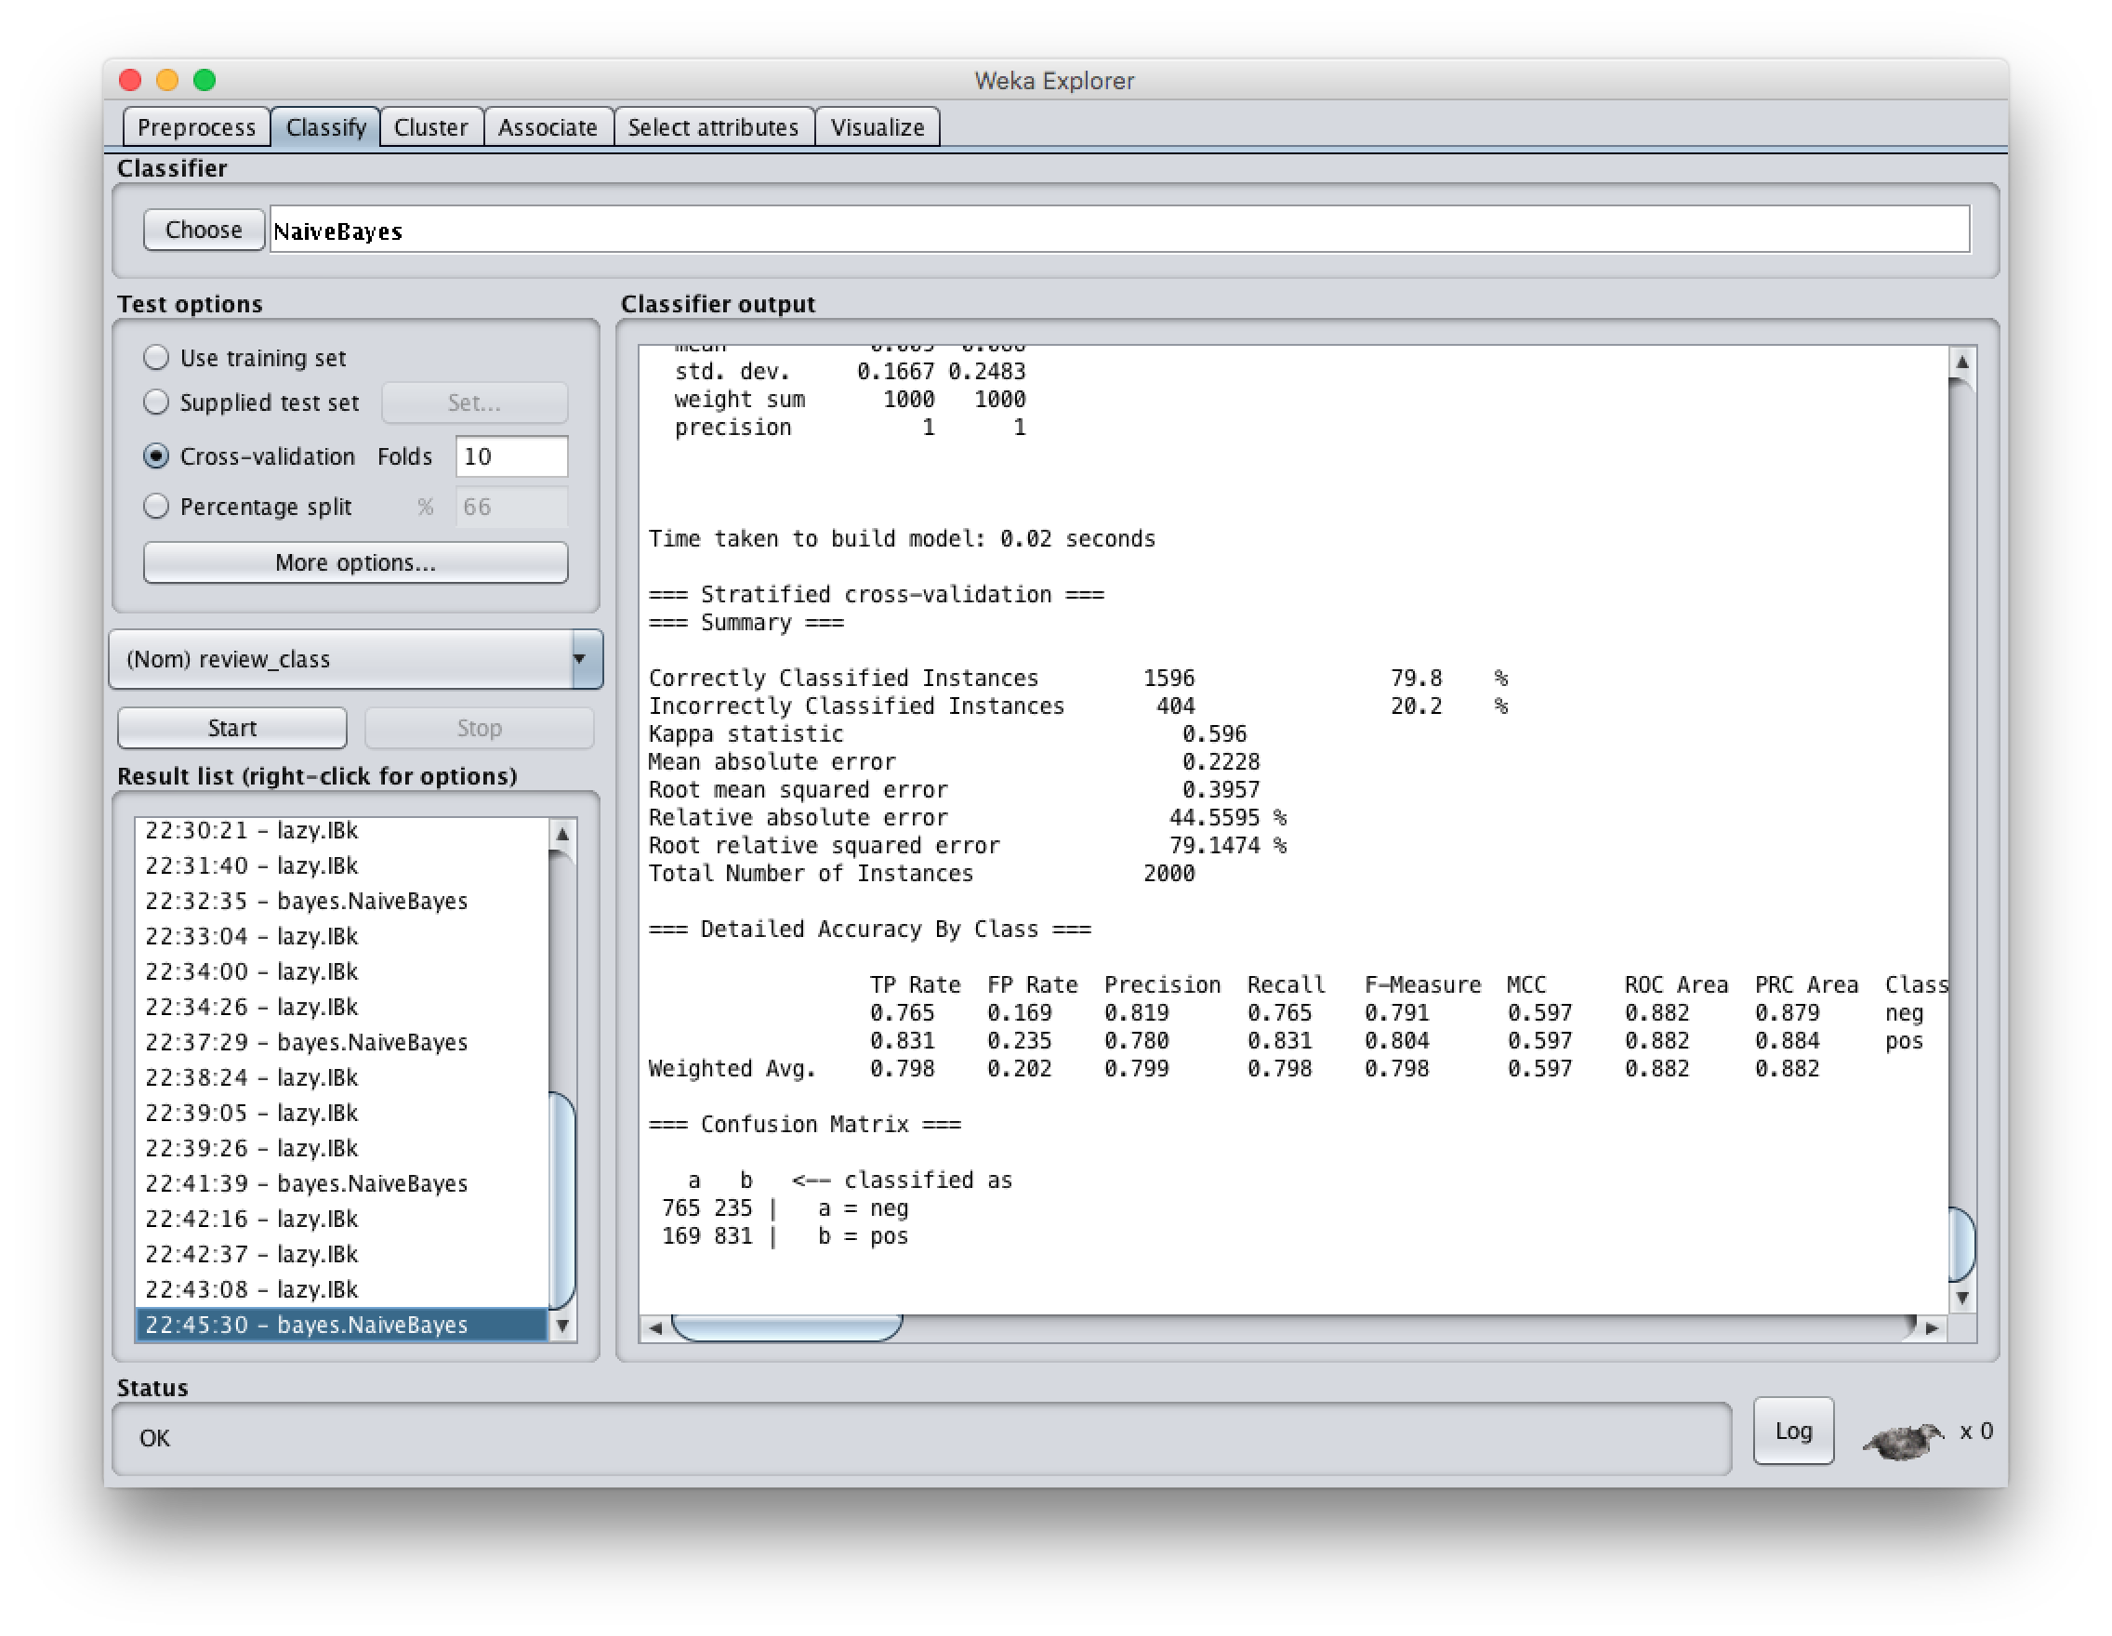  
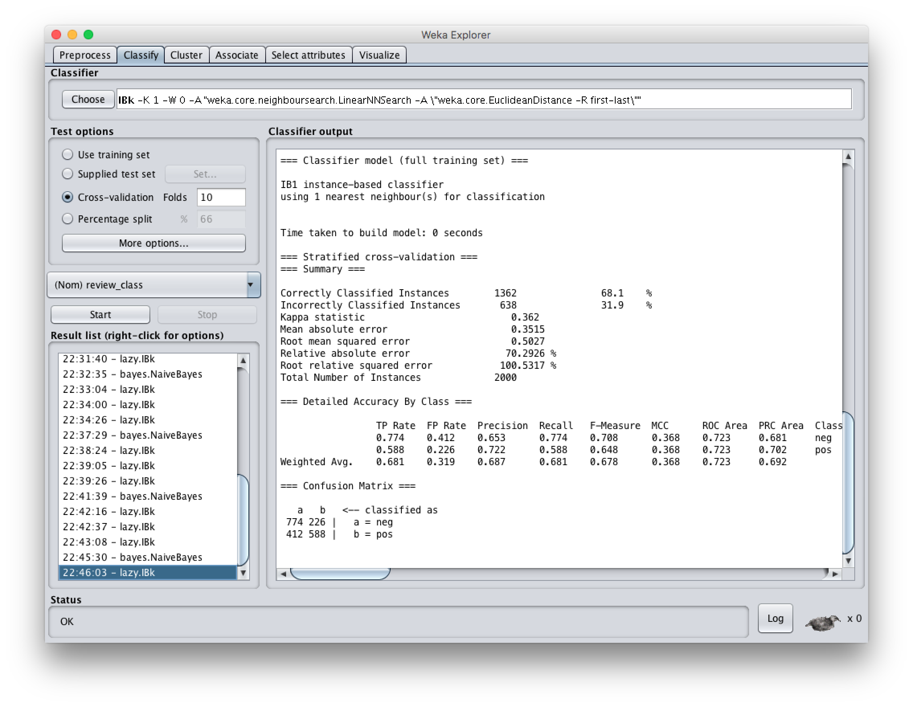

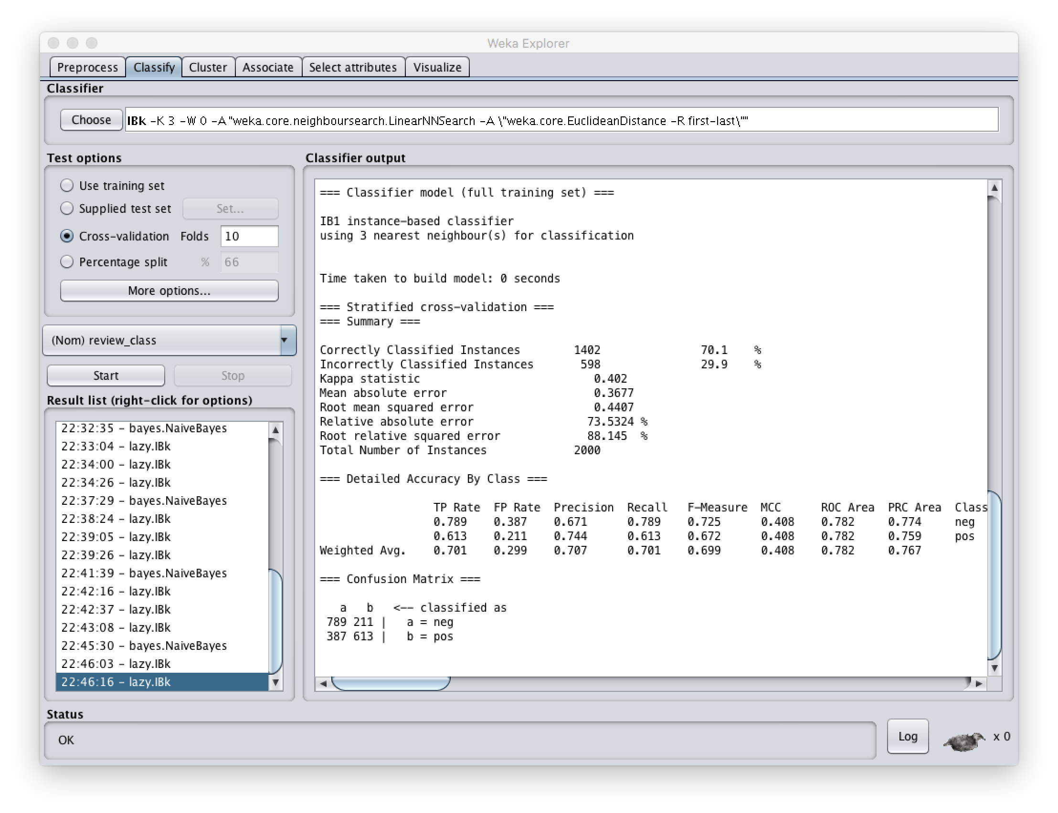

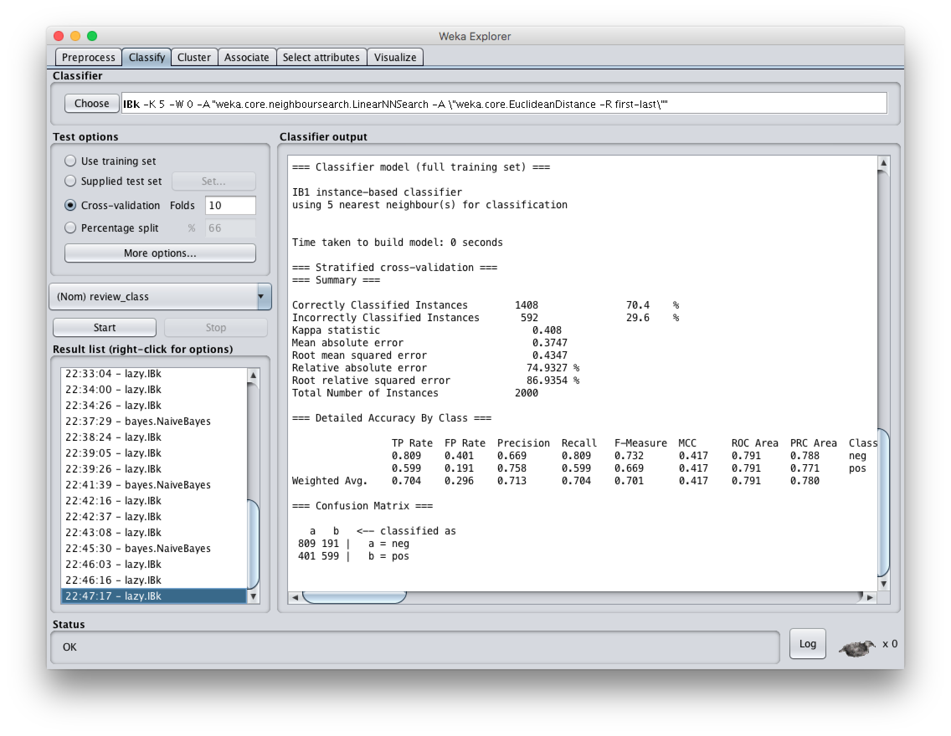

#4:

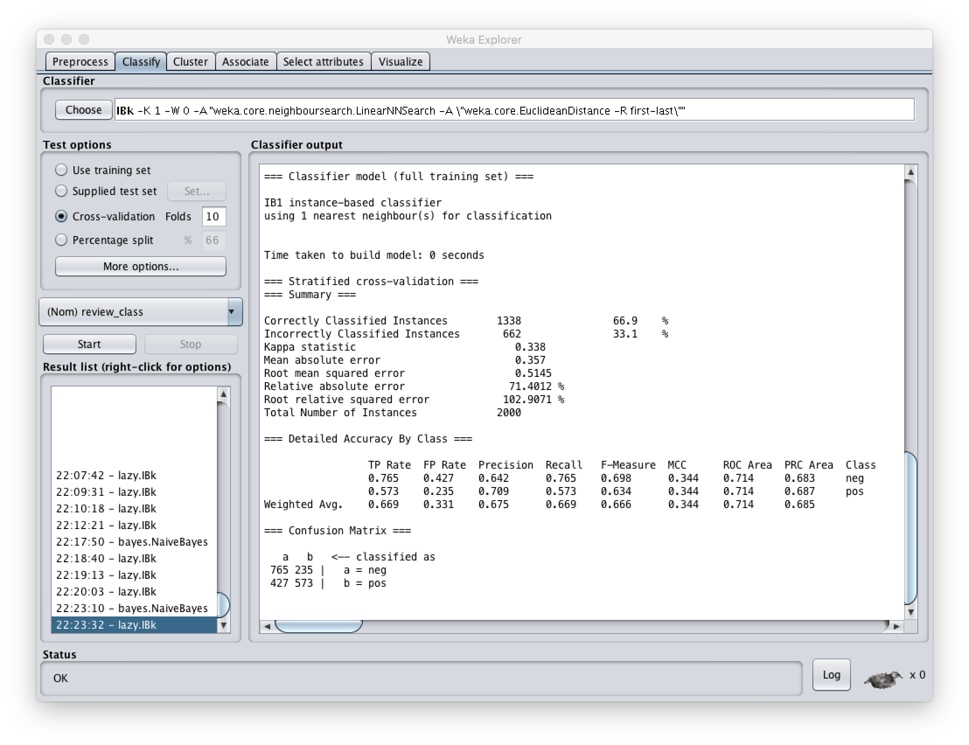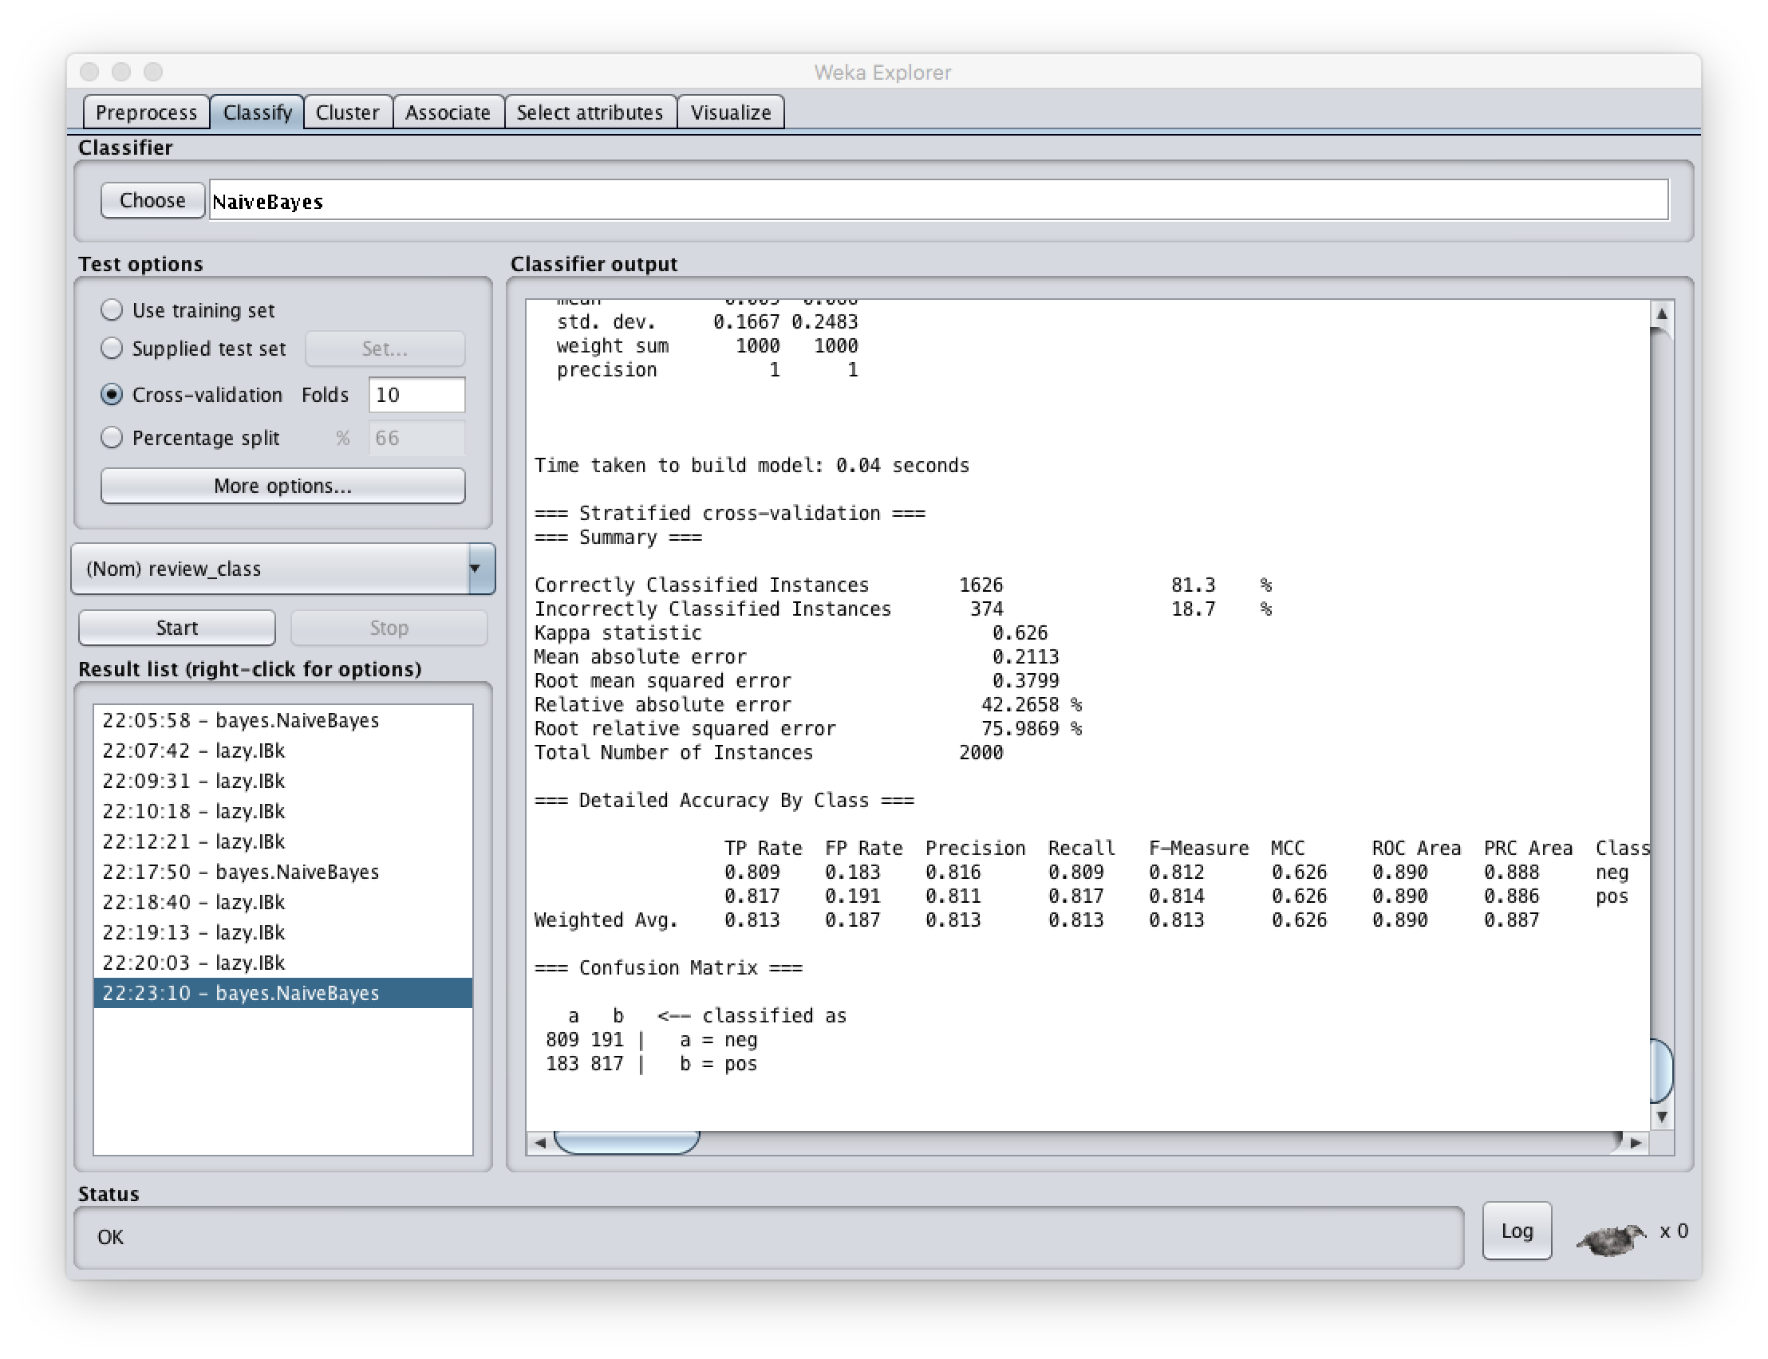

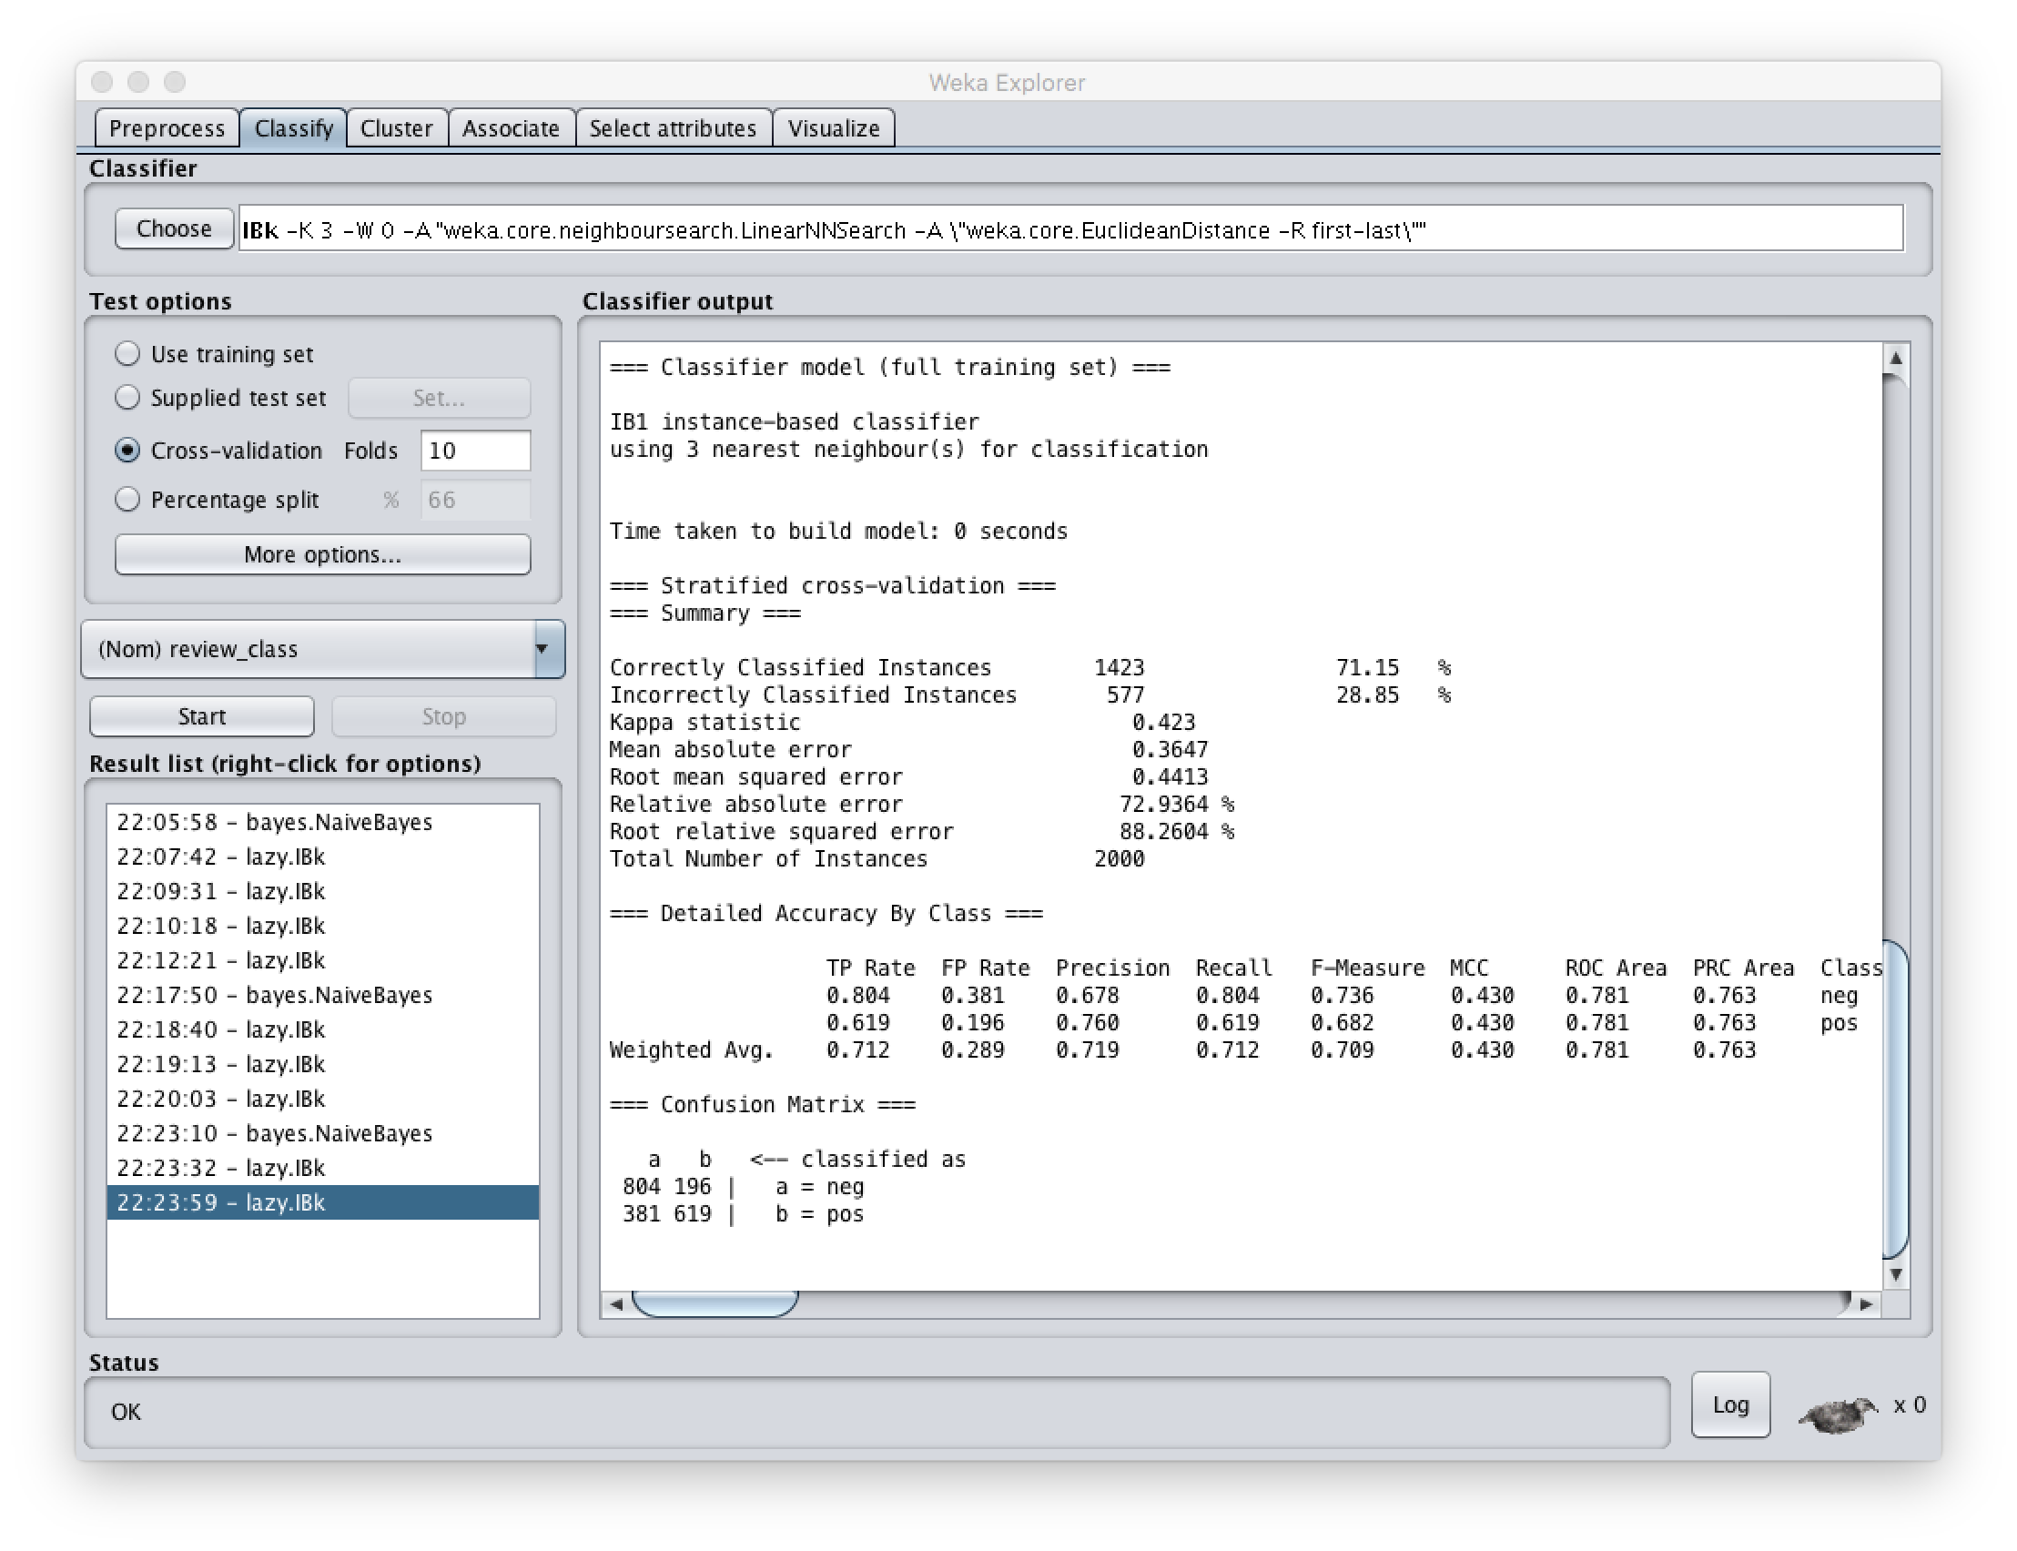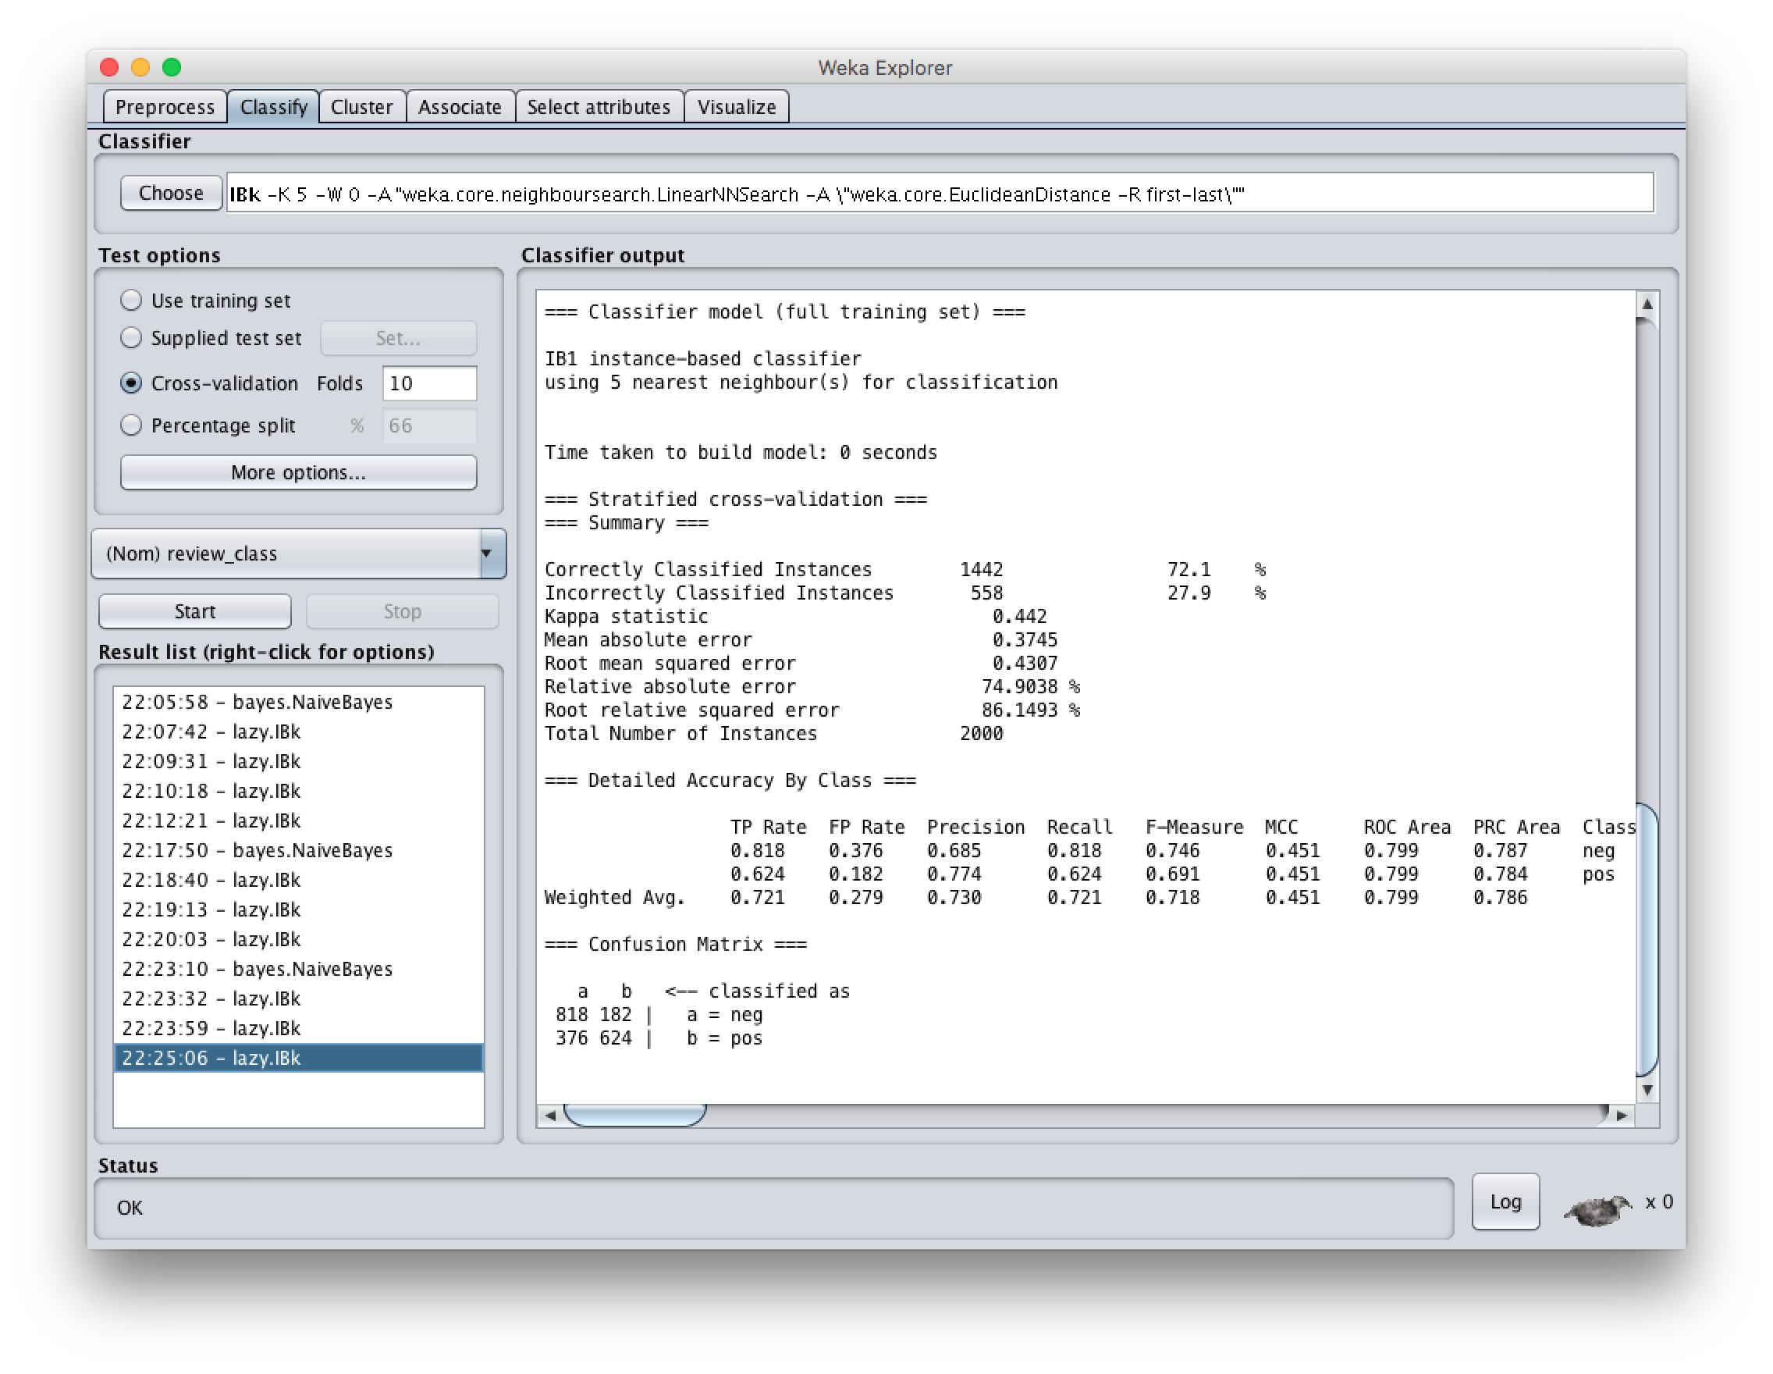

#5:

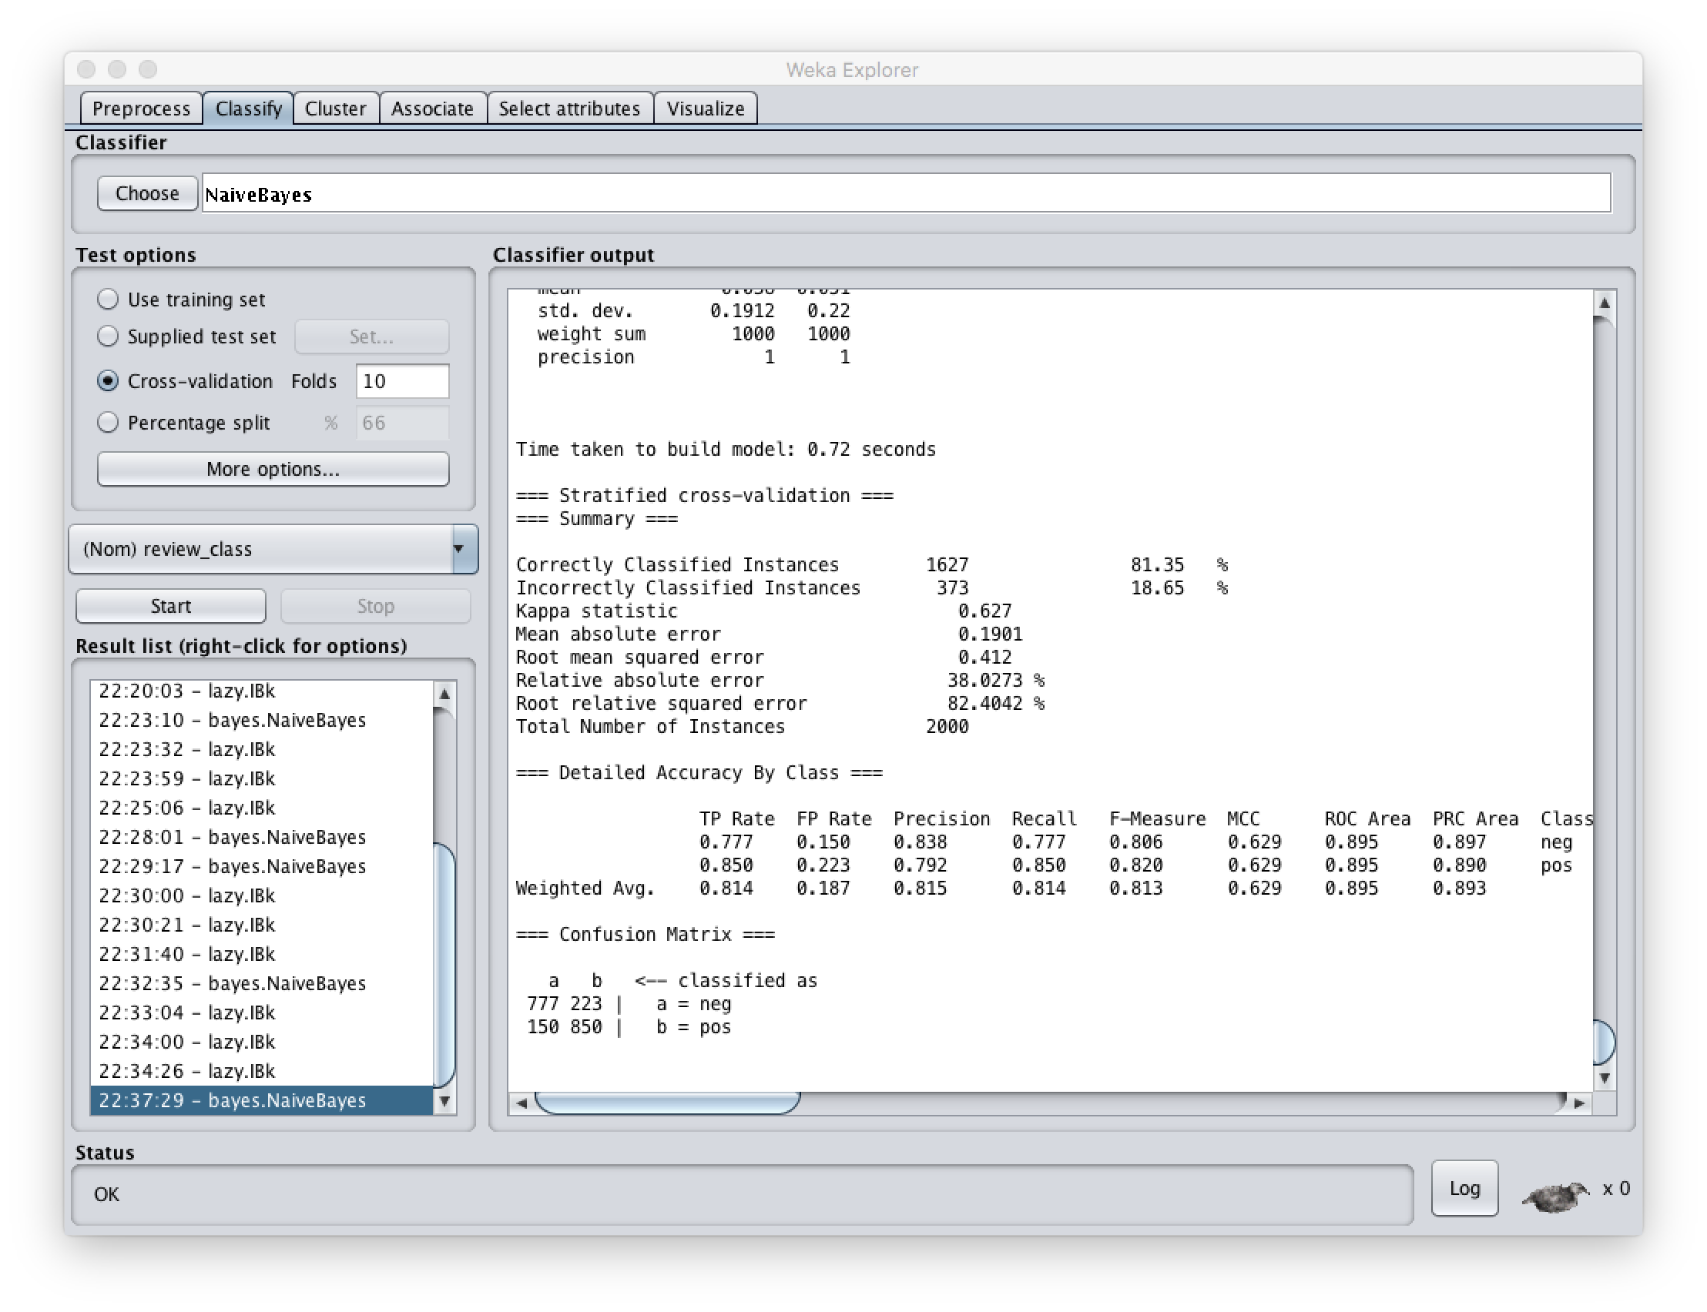

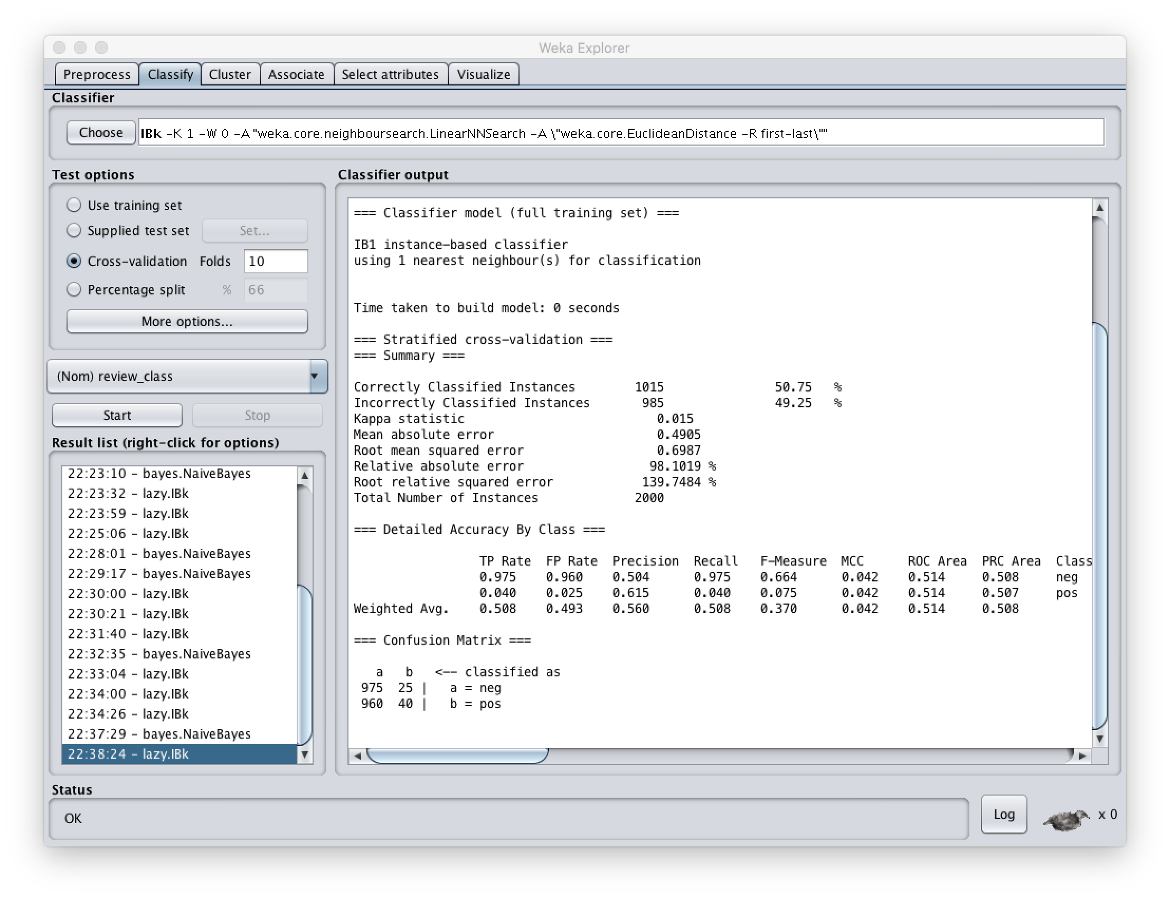

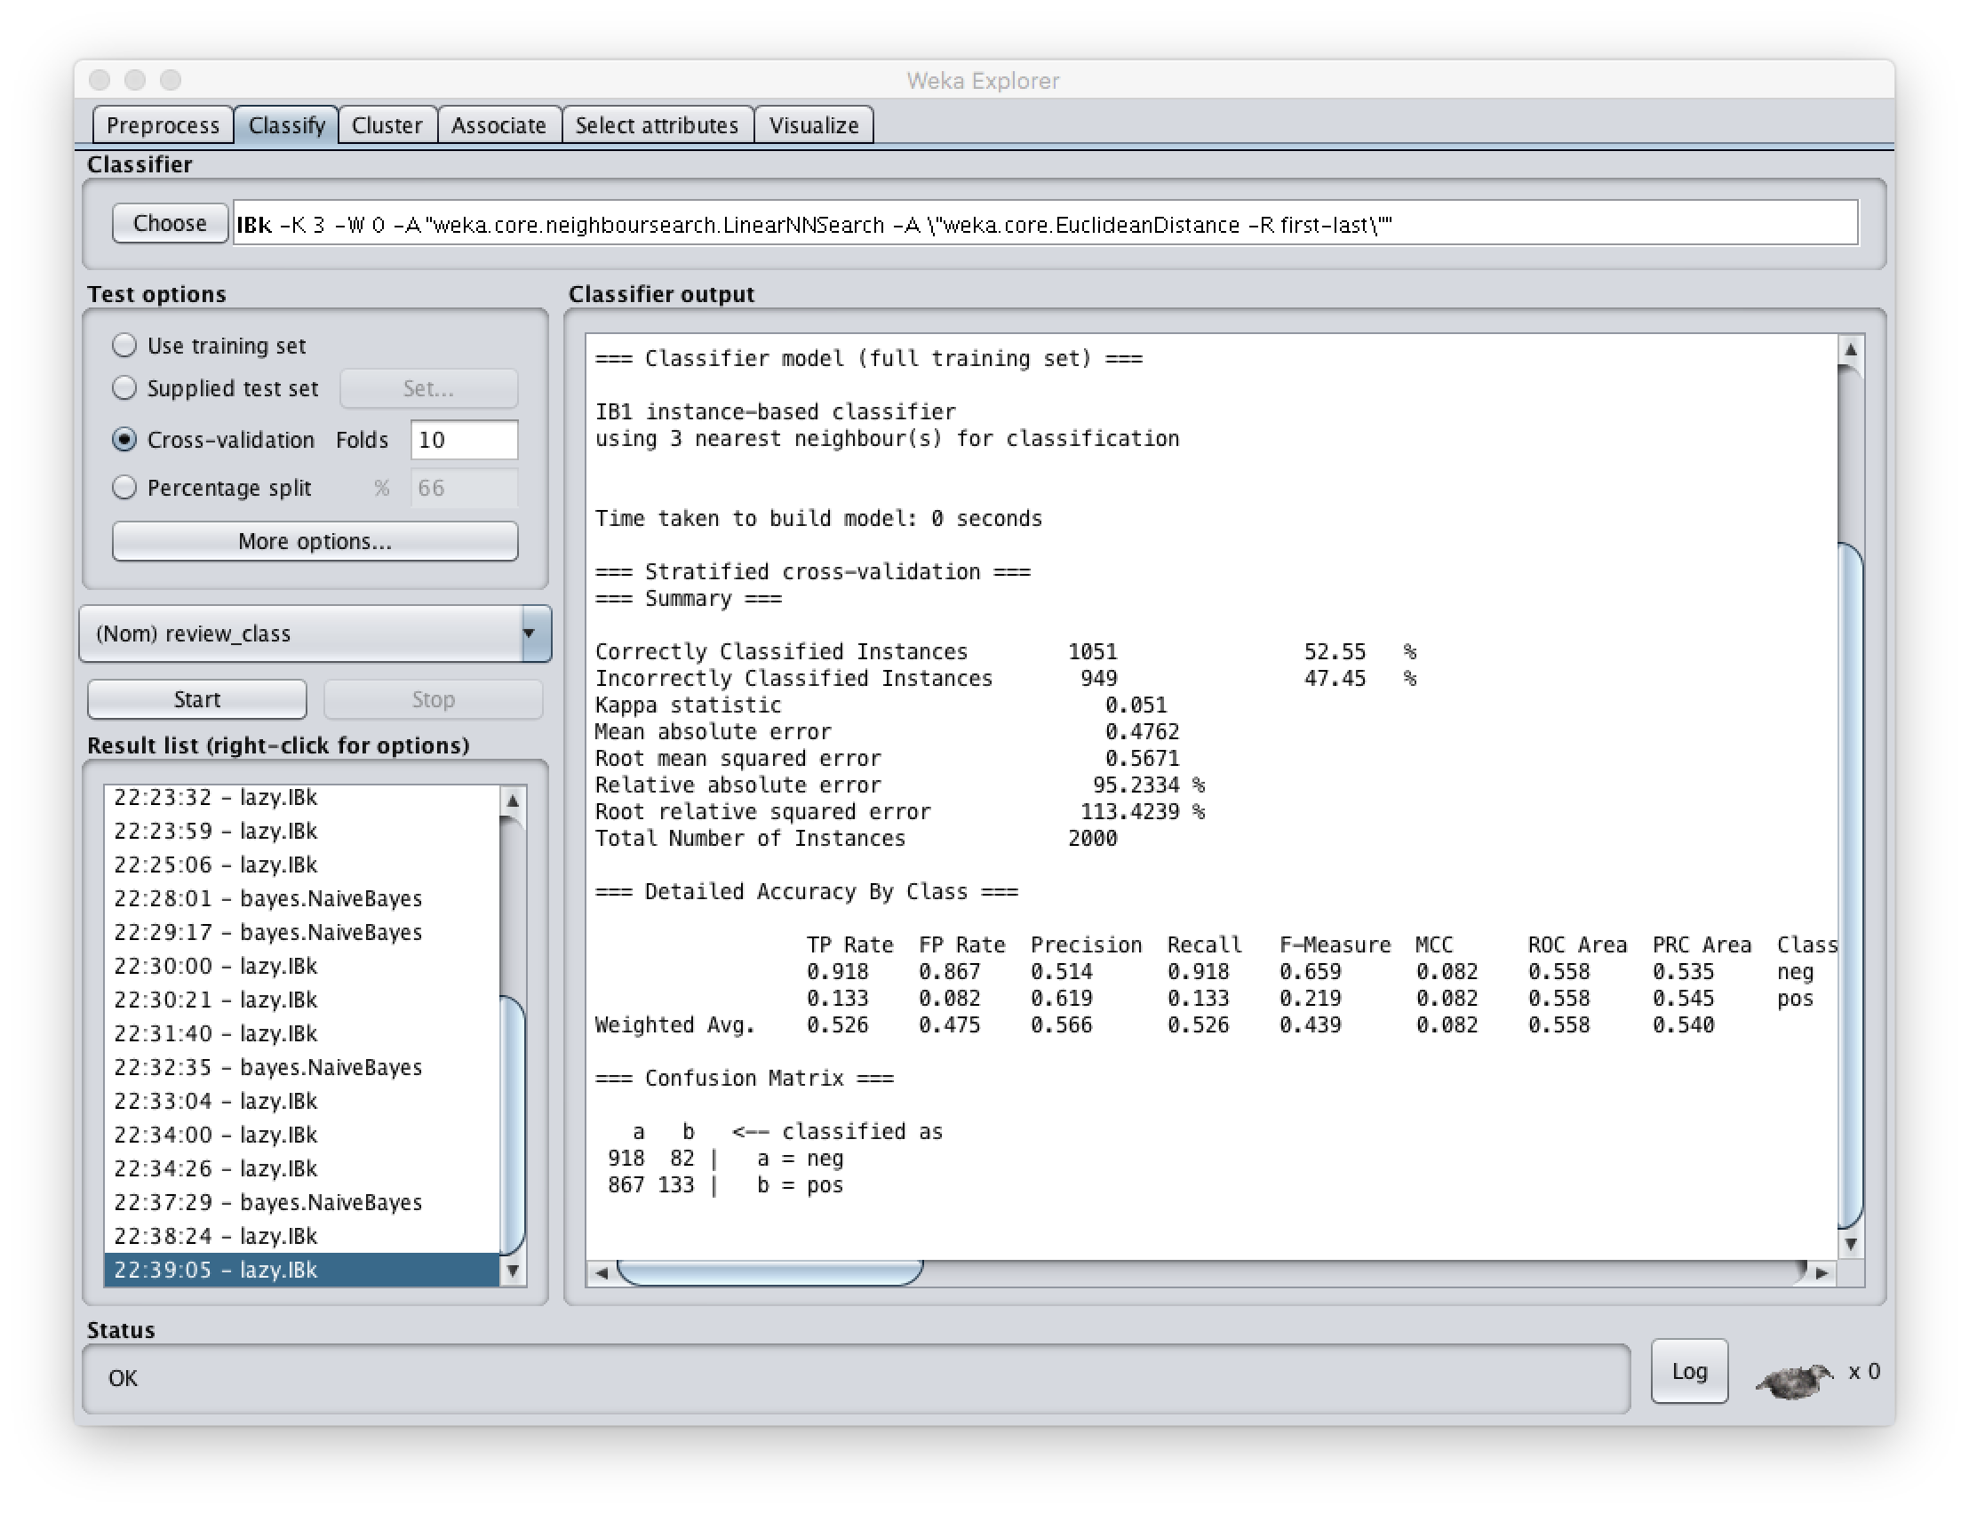

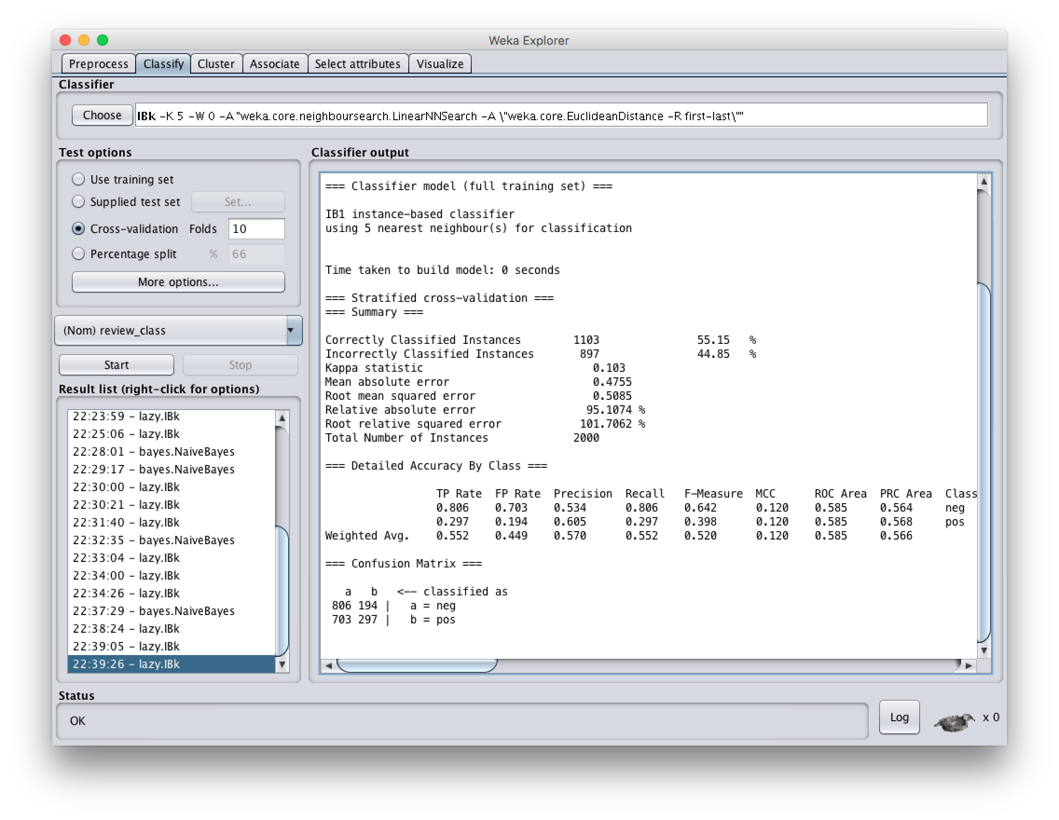

#6:

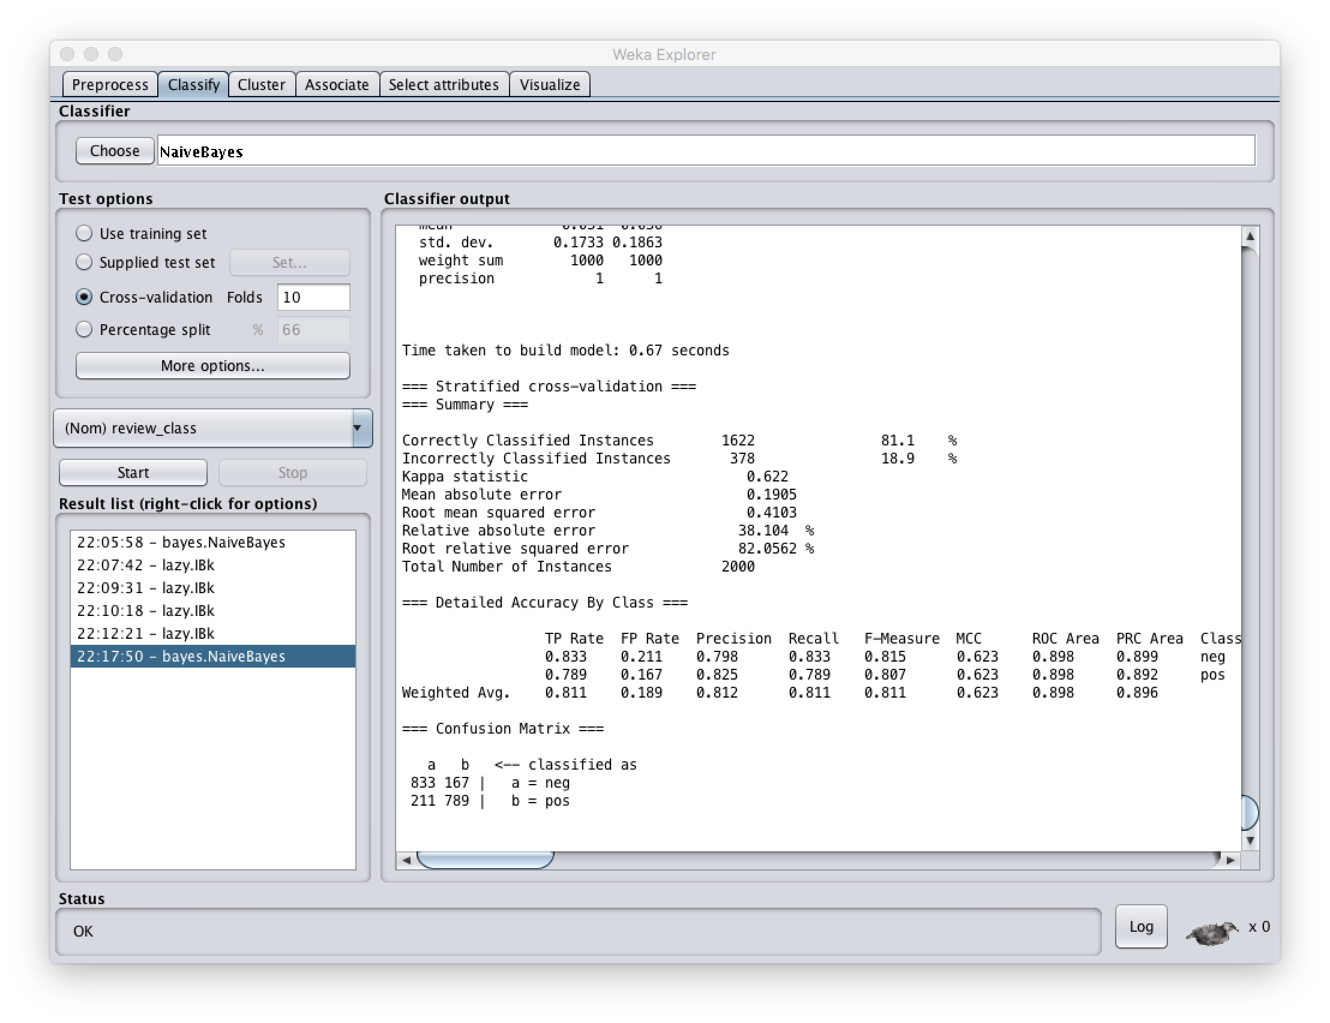

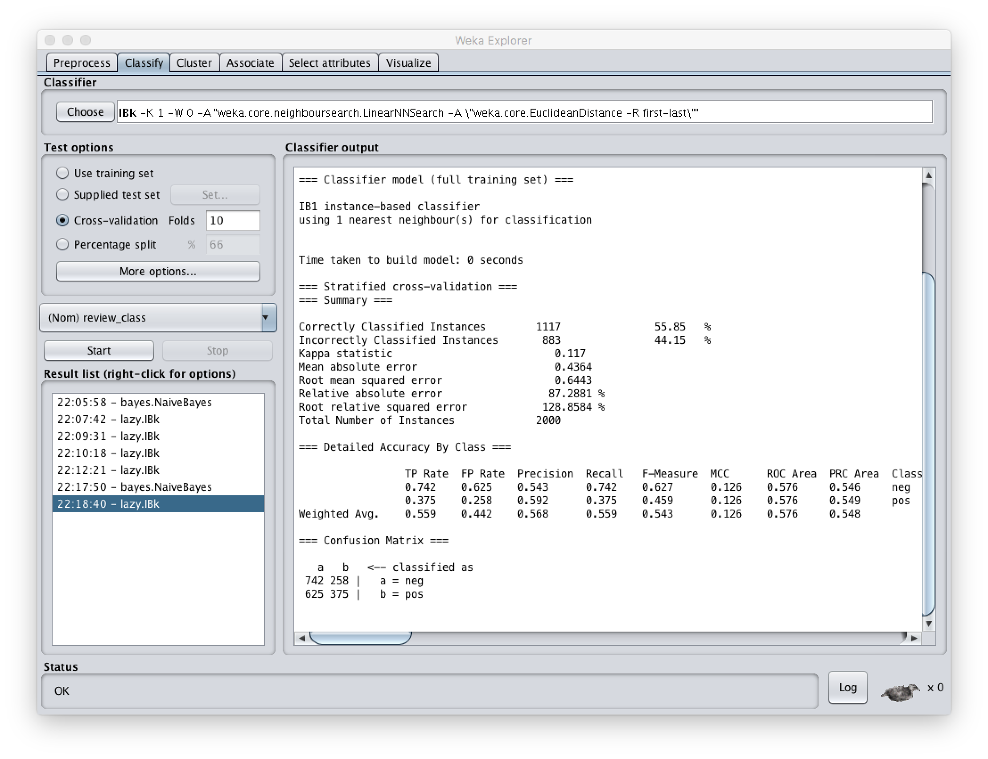

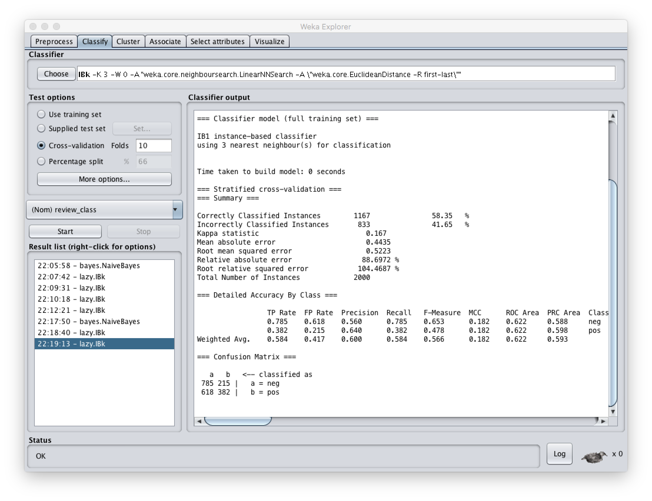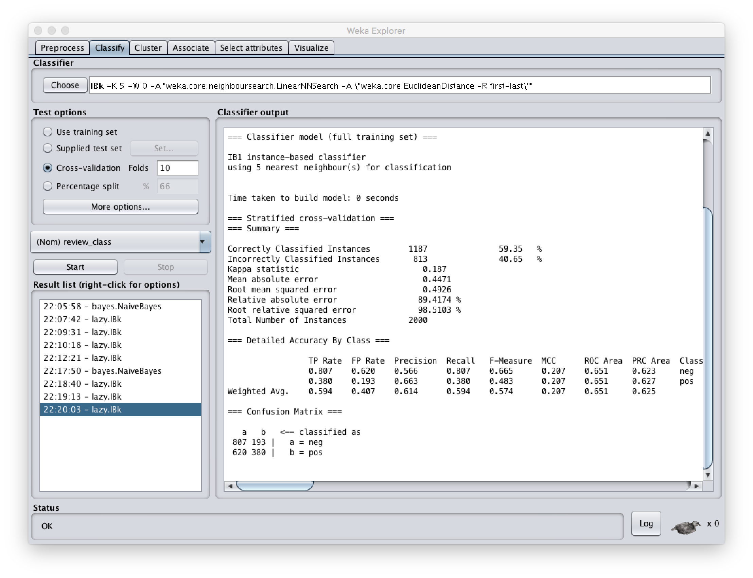

#7:

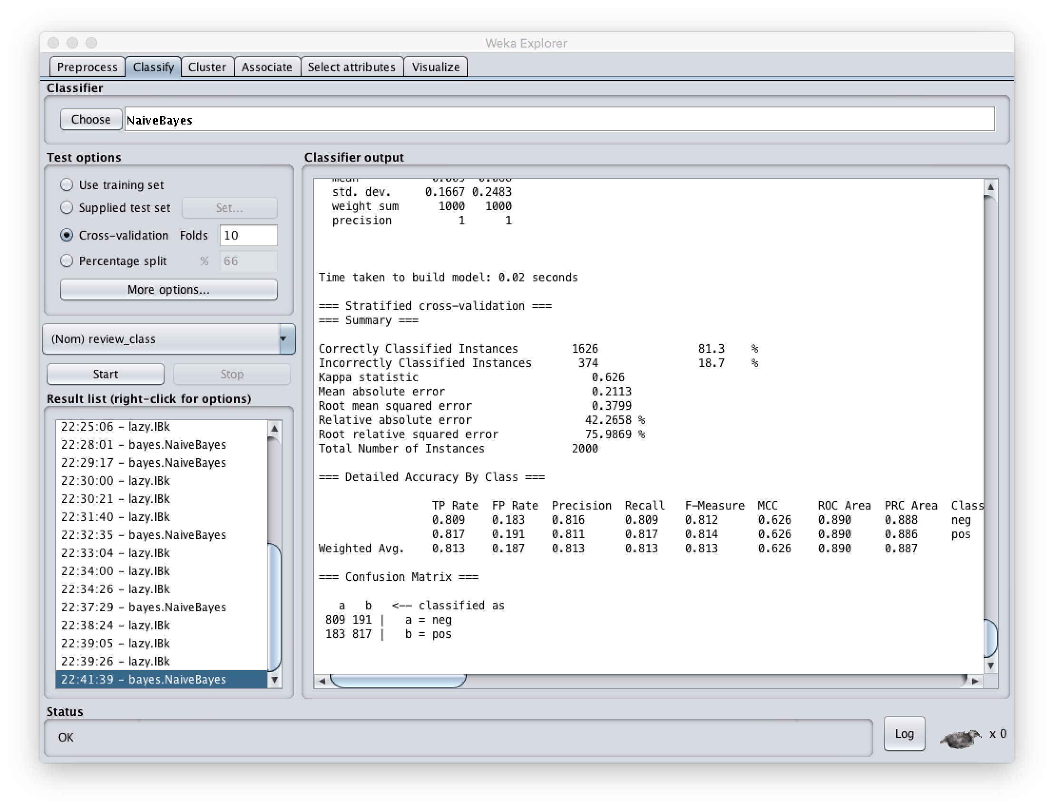

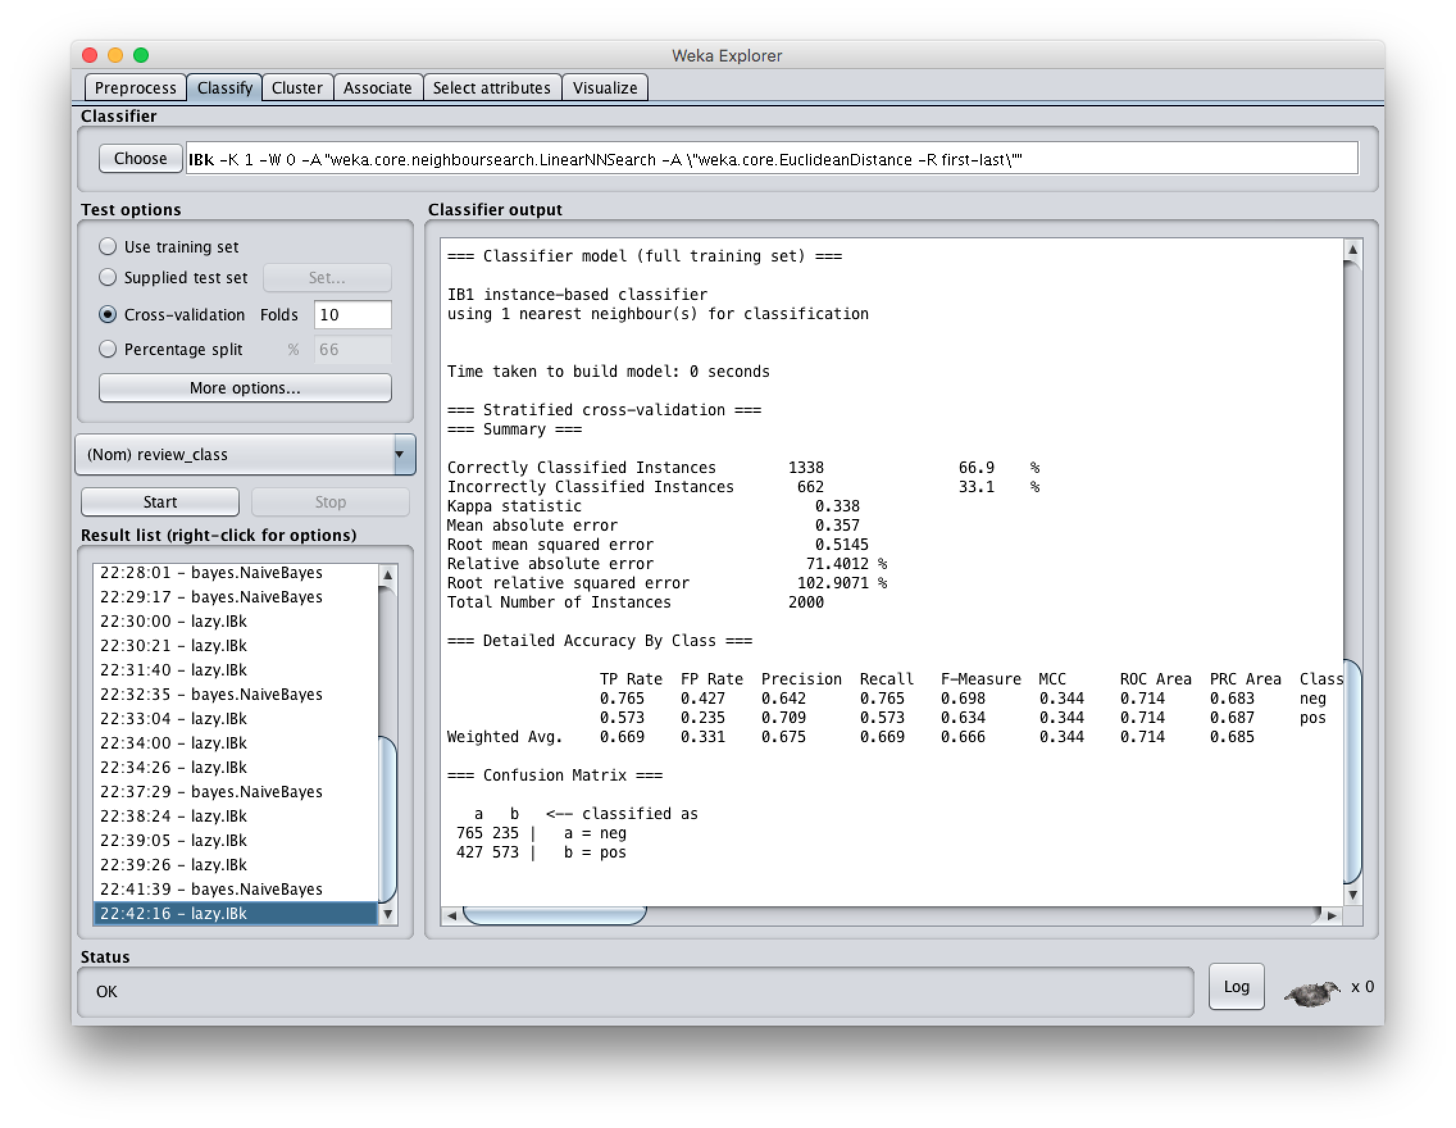

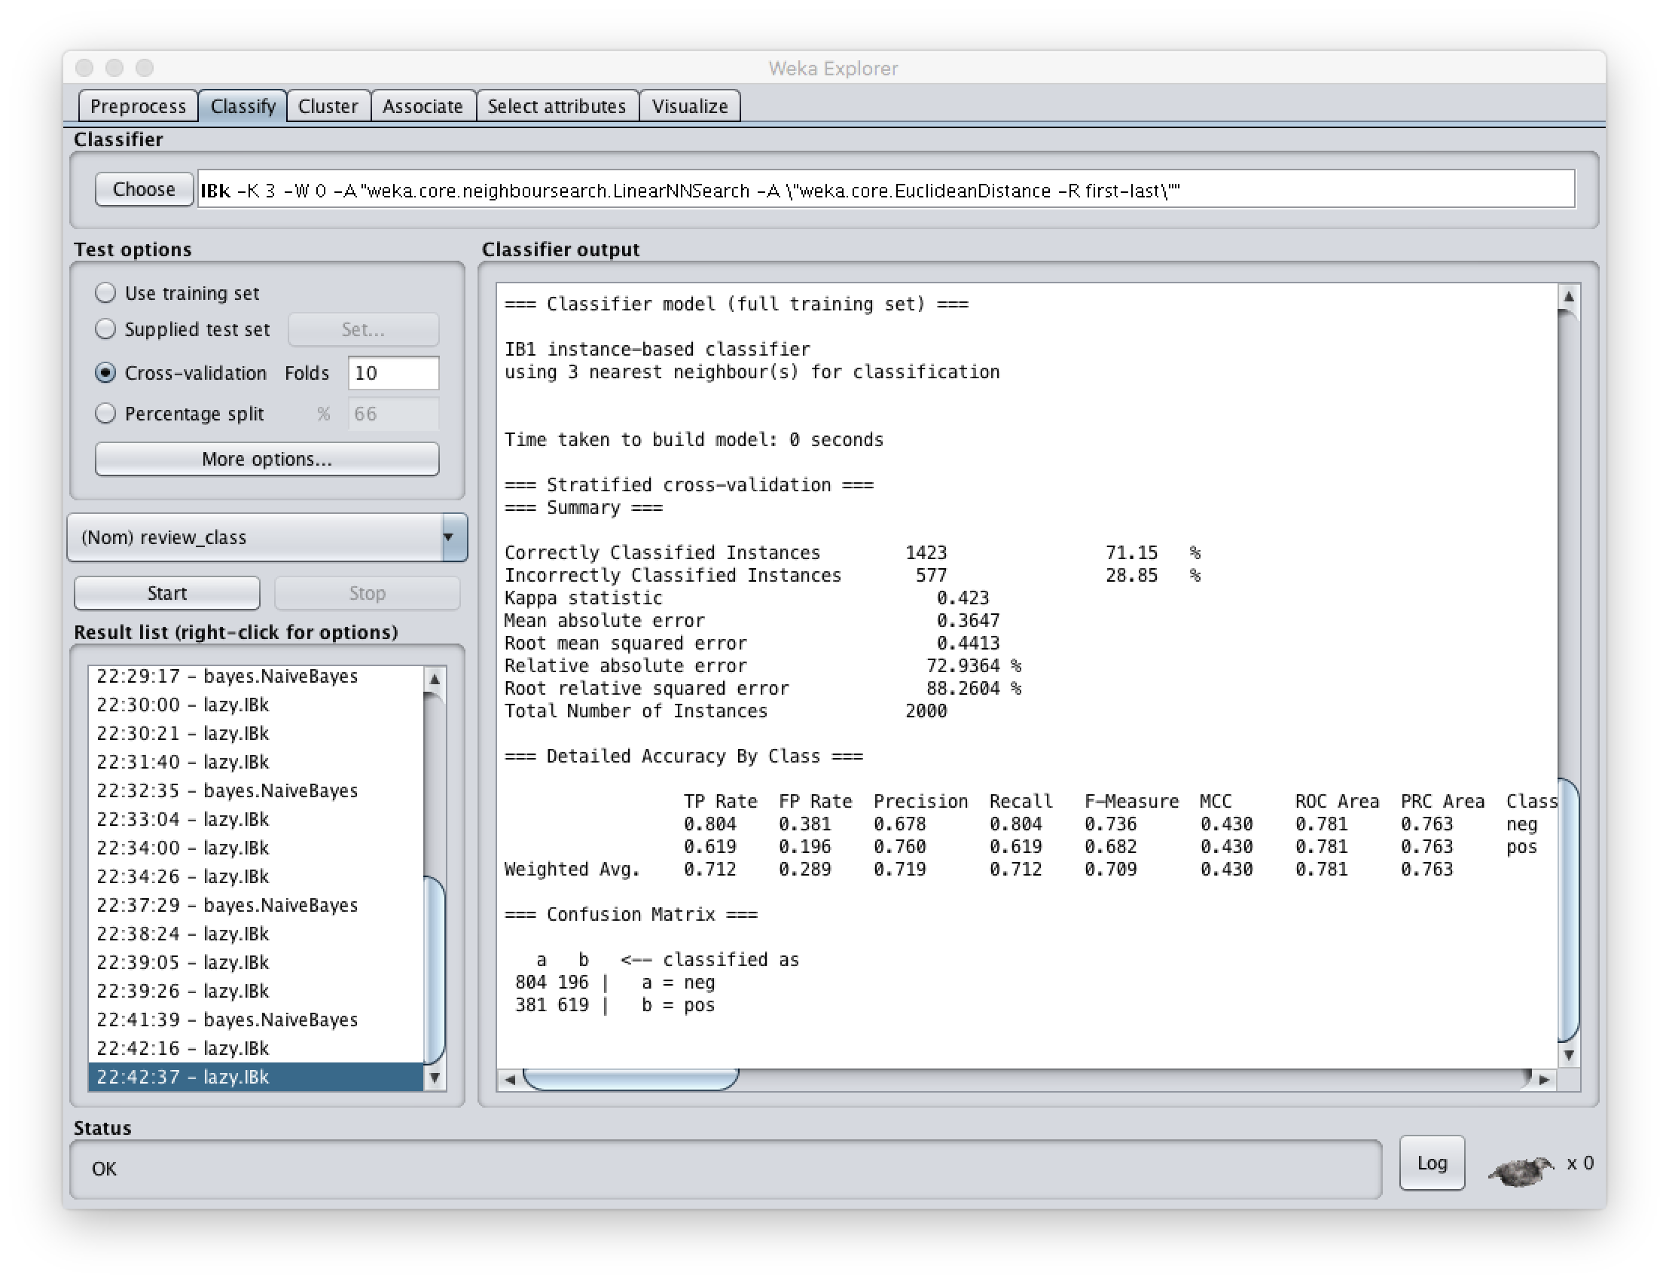

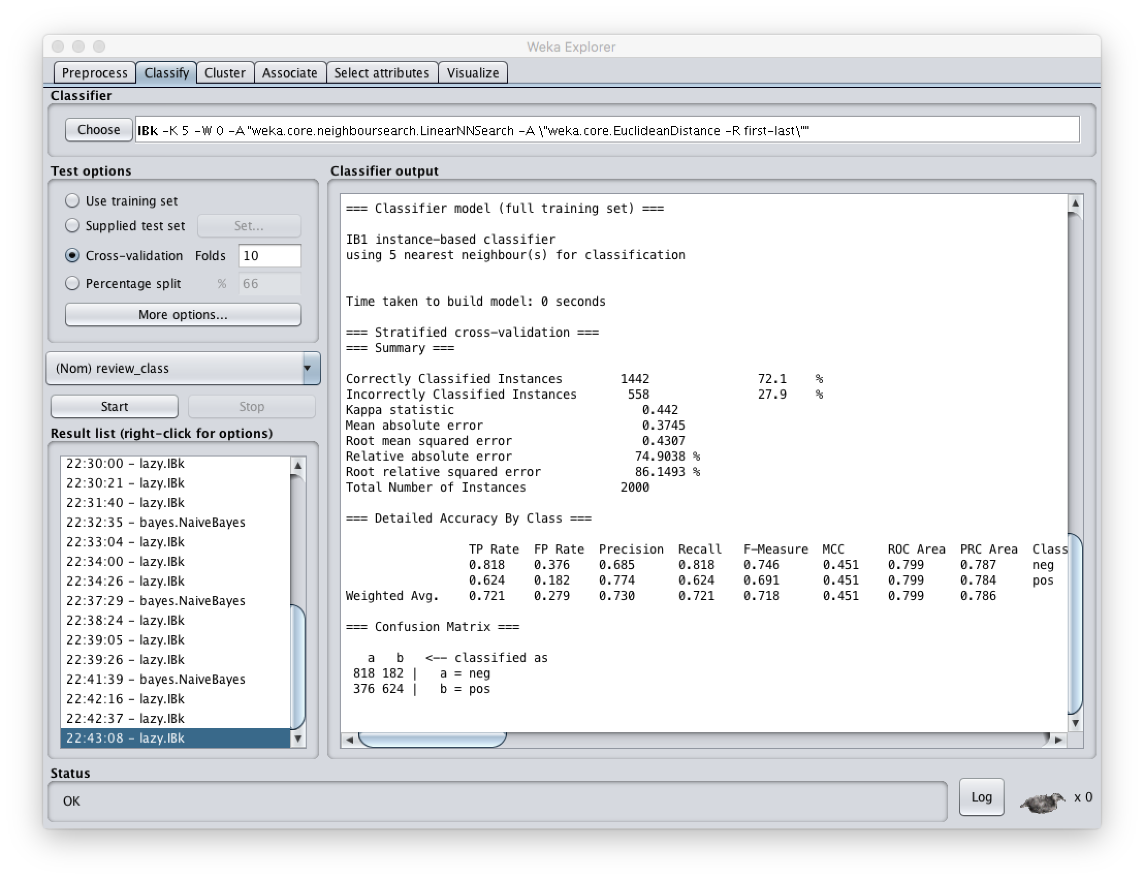

#8:

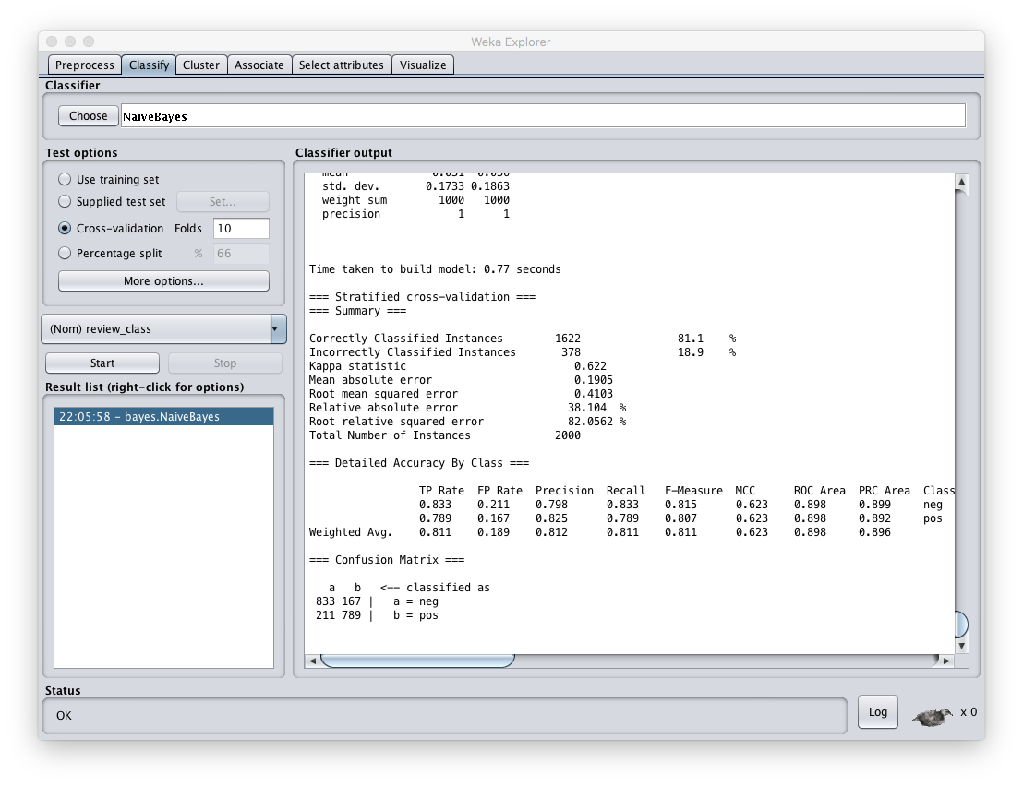

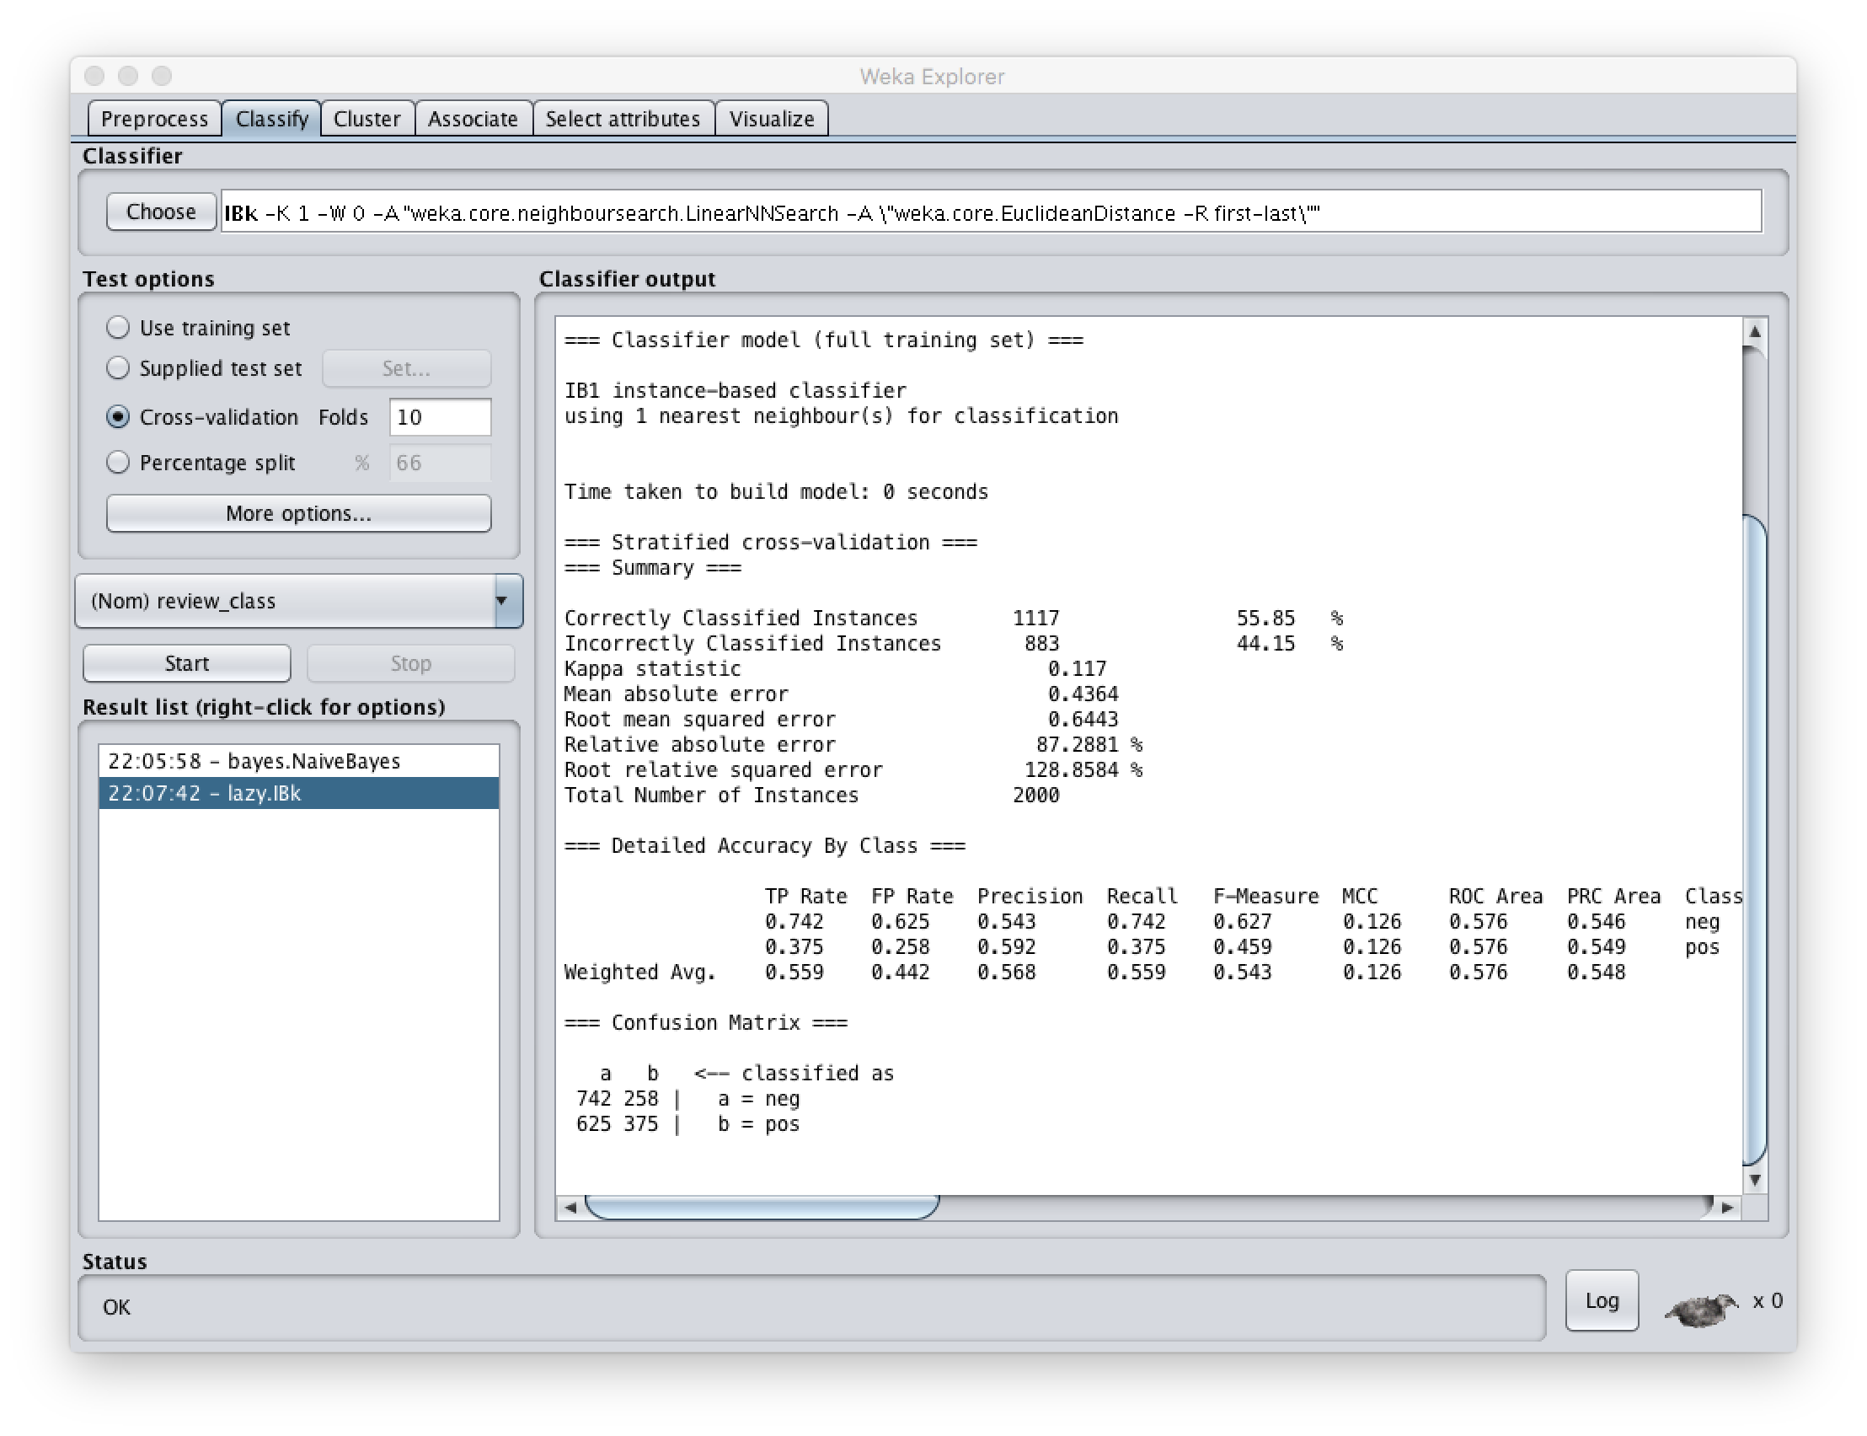

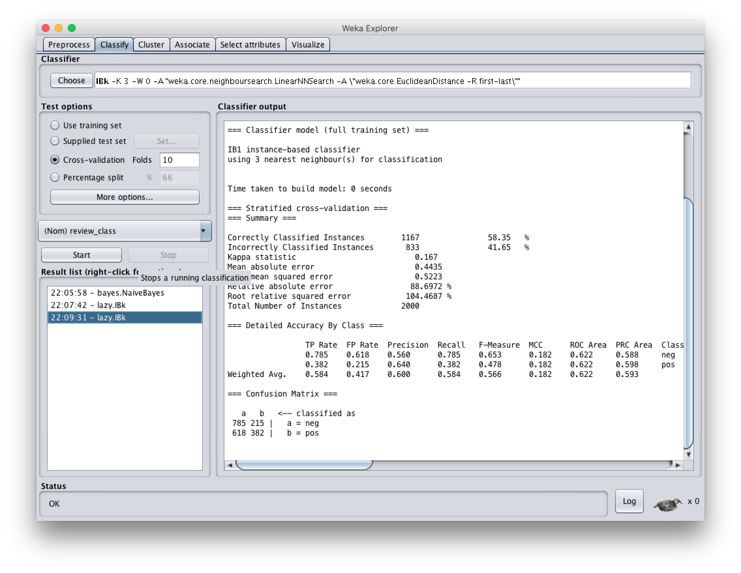

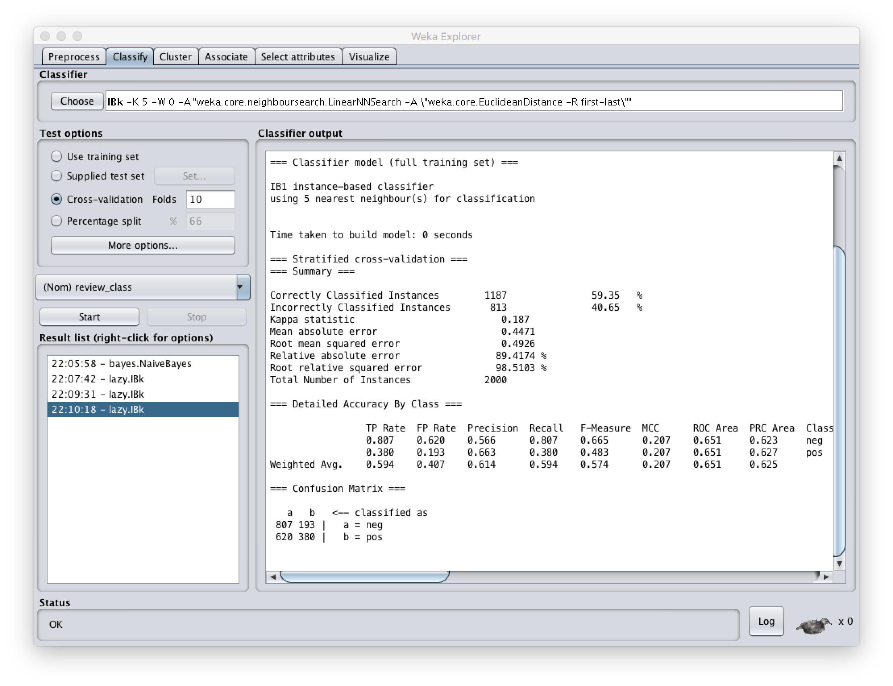

|  |  |  |  |  |  |  |  |
| --- | --- | --- | --- | --- | --- | --- | --- |
| # | Stemming | Stop-words removal | Attribute Selection | Naïve Bayes | Nearest neighbor | 3-NN | 5-NN |
| 1 | YES | YES | YES | 80.6% | 70.75% | 73.2% | 74.15% |
| 2 | YES | YES | NO | 80.95% | 52.8% | 54.15% | 55.15% |
| 3 | NO | YES | YES | 79.8% | 68.1% | 70.1% | 70.4% |
| 4 | YES | NO | YES | 81.3% | 66.9% | 71.15% | 72.1% |
| 5 | NO | YES | NO | 81.35% | 50.75% | 52.55% | 55.15% |
| 6 | YES | NO | NO | 81.1% | 55.85% | 58.35% | 59.35% |
| 7 | NO | NO | YES | 81.3% | 66.9% | 71.15% | 72.1% |
| 8 | NO | NO | NO | 81.1% | 55.95% | 58.35% | 59.35% |